Project number 2020-1-TR01-KA202-093467

**POWER UP MY HOUSE**

**OUTPUT 5. EDUCATION MATERIAL**

2022

Contents

INTRODUCTION 3

1. SOLAR ENERGY 4

2. SOLAR PHOTOVOLTAIC TECHNOLOGY (PV) 6

2.1. The working principle of a solar cell 6

2.1.1. Generation of charge carriers due to the absorption of photons in the materials that form a junction 6

2.1.3. Collection of the photo-generated charge carriers at the terminals of the junction 8

2.2. PV module operation 9

2.2.1. PV Module Safety Rules 12

2.2.2. PV characteristics 15

2.2.3. Photovoltaic arrays 21

2.3. Solar PV system 31

2.3.1. Charge controlled PV system 31

2.3.2. An inverter 35

2.3.3. Batteries 39

3. PHOTOVOLTAIC–THERMAL TECHNOLOGY (PV/T) 47

3.1. PVT collector classification 49

3.2. Performance of PVT Collectors 51

3.2.1. Air PV/T systems 52

3.2.2. Liquid PV/T systems 53

3.2.3. Heat Pipe PV/T systems 53

3.2.4. PV/T systems with PCM 54

3.2.5. Heat Pump Integrated with a PV/T Collector 55

4. EXPERIMENT 57

4.1. Research of photovoltaic cells 57

4.2. Principal operation of the stand 950-STCL1 (Solar thermal collector) 59

References 61

# INTRODUCTION

The PV/T training module we developed was developed as part of the Power Up My House project (project no.: 2020-1-TR01-KA202-093467), funded by the European Commission. This module is a teaching material in which theoretical knowledge will be visually and experimentally enhanced for students studying in the field of renewable energy technologies or for those who wish to have knowledge and skills in the subject. The training module aims to reinforce theoretical knowledge with visual and experimental material. The “Solar Element (PV) and Hot Water (ST) Training Kit” manufactured by Amatrol was used as the experimental kit, and the experiments provided basic information on PV and ST energy production and applicable theoretical equations. It is considered that PV / T systems can be taught as an optional course in the fields of renewable energy technologies and installation technologies.

# SOLAR ENERGY

The Sun is the energy source for almost all the processes happening on the surface of our planet: wind is a result of temperature difference in the atmosphere induced by solar irradiation; waves are generated by the wind; clouds and rain are initially formed by the evaporation of water due to sunlight. As the Sun is the only real energy source we have, we need to move to an era in which we start to utilize the energy provided by the sun directly for satisfying our energy needs.

The sun is the most powerful source of renewable energy on Earth. Although the relative intensity of solar radiation on its surface reaches 6,318*107 W/m2, due to the scattering of rays propagating at a spherical angle in space, the relative intensity of radiation reaching the Earth's atmospheric surface decreases tens of thousands of times and make up to only 1362 W/m2 (Figure 1). The density of solar energy reaching the surface of the Earth's atmosphere (1362 W/m2) is called the solar constant. However, even at this intensity, the total amount of solar energy reaching the Earth is thousands of times greater than the current energy consumption of all mankind.

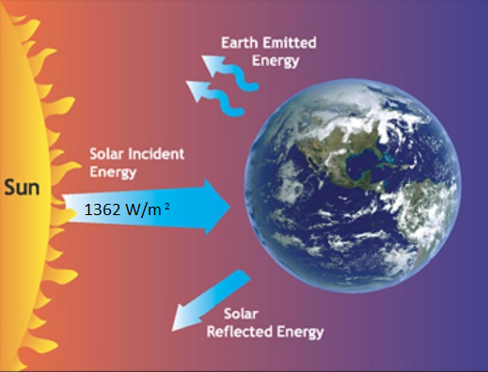

Fig. 1. Solar energy flow

The theoretical annual global solar energy potential is estimated at 900,000,000 TWh and is about 60 times the theoretical annual global wind energy potential, about 2,200 times the theoretical annual geothermal energy potential, about 4,500 times the biomass and about 36,000 times the for the theoretical annual global potential of hydropower. Despite this size, the potential for solar energy to generate electricity and heat is still the least used. This is not a coincidence: the solar energy itself is scattered, poorly concentrated, and its parameters vary widely depending on the time of day and the time of year.

Lithuania's geographical latitude is less favorable for the use of solar energy than in countries closer to the equator, such as Malta or Cyprus. The maximum sunlight is at the equator. As you move away from the equator, the radiation decreases. The countries at the bottom receive the most solar energy and the top receive the least (Figure 2).

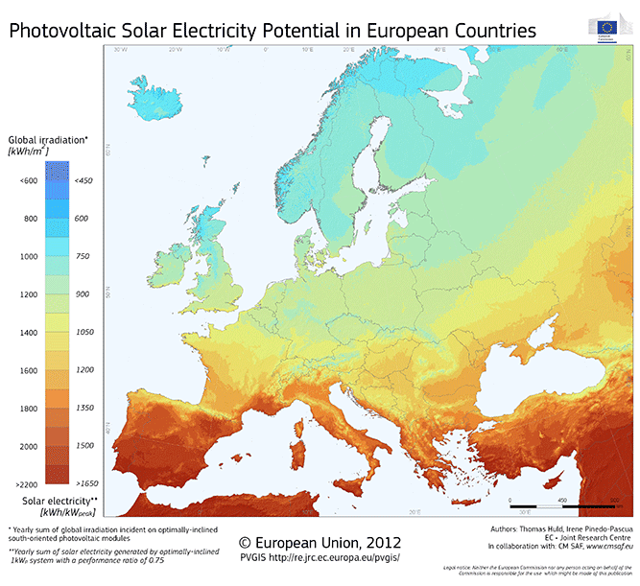

Fig. 2. Solar energy for the European continent [1]

In Lithuania, the annual amount of solar energy falling on a horizontal surface of 1 m2 is slightly higher than 1000 kWh/m2 (leading in Europe in the south of Germany - 1260 kWh/m2, in the north 970 kWh/m2, in Spain about 1500 kWh/m2. Thus, climatic conditions for solar energy in Lithuania it is slightly worse than in Germany, but better or similar than in Belgium, Denmark or Great Britain.

Monthly values and the average in a year, for a specific place are shown in Figure 3.



Fig. 3. Monthly insolation values in a year [2]

Solar energy is used as a renewable energy source to generate electricity and heat.

A solar cell, or photovoltaic cell (PV), is an electrical device that converts the energy of light directly into electricity by the photovoltaic effect, which is a physical and chemical phenomenon.

Solar thermal energy (ST) is a form of energy and a technology for harnessing solar energy to generate thermal energy for use in industry, and in the residential and commercial sectors.

Photovoltaic–thermal (PV/T) is the combination of PV technology and solar thermal technology, which converts the incident radiation into electricity and heat simultaneously.

# SOLAR PHOTOVOLTAIC TECHNOLOGY (PV)

## The working principle of a solar cell

The working principle of solar cells is based on the photovoltaic effect, i.e. the generation of a potential difference at the junction of two different materials in response to electromagnetic radiation. The photovoltaic effect is closely related to the photoelectric effect, where electrons are emitted from a material that has absorbed light with a frequency above a material-dependent threshold frequency. In 1905, Albert Einstein understood that this effect can be explained by assuming that the light consists of well defined energy quanta, called photons. The energy of such a photon is given by

$E=h$, (1)

where *h* is Planck’s constant and *ν* is the frequency of the light. For his explanation of the photoelectric effect Einstein received the Nobel Prize in Physics in 1921.

The photovoltaic effect can be divided into three basic processes [3]:

### 2.1.1. Generation of charge carriers due to the absorption of photons in the materials that form a junction

Absorption of a photon in a material means that its energy is used to excite an electron from an initial energy level *Ei* to a higher energy level *Ef*, as shown in Figure 4 (a). Photons can only be absorbed if electron energy levels *Ei* and *Ef* are present so that their difference equals the photon energy, *hν* = *Ef* − *Ei*. In an ideal semiconductor electron can populate energy levels below the so-called valence band edge, *EV*, and above the so-called conduction band edge, *EC*. Between those two bands no allowed energy states exist which could be populated by electrons. Hence, this energy difference is called the bandgap, *EG = EC − EV*. If a photon with an energy smaller than *EG* reaches an ideal semiconductor, it will not be absorbed but will traverse the material without interaction.

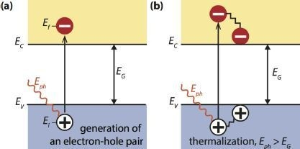

Fig. 4:(a) Illustrating the absorption of a photon in a semiconductor with bandgap *EG*. The photon with energy *Eph= hν* excites an electron from *Ei* to *Ef*. At *Ei* a hole is created. (b) If *Eph* > *EG*, a part of the energy is thermalized [3].

In a real semiconductor, the valence and conduction bands are not flat, but vary depending on the so-called k-vector that describes the momentum of an electron in the semiconductor. This means that the energy of an electron is dependent on its momentum because of the periodic structure of the semiconductor crystal. If the maximum of the valence band and the minimum of the conduction band occur at the same k-vector, an electron can be excited from the valence to the conduction band without a change in the momentum. Such a semiconductor is called a direct bandgap material. If the electron cannot be excited without changing its momentum, we refer to it as an indirect bandgap material. The electron can only change its momentum by momentum exchange with the crystal, i.e. by receiving momentum from or giving momentum to vibrations of the crystal lattice. The absorption coefficient in a direct bandgap material is much higher than in an indirect bandgap material, thus the absorbing semiconductor, often just called the absorber, can be much thinner.

If an electron is excited from *Ei* to *Ef*, a void is created at *Ei*. This void behaves like a particle with a positive elementary charge and is called a hole. The absorption of a photon therefore leads to the creation of an electron-hole pair, as illustrated in Figure 5(1). The radiative energy of the photon is converted to the chemical energy of the electron-hole pair. The maximal conversion efficiency from radiative energy to chemical energy is limited by thermodynamics. This thermodynamic limit lies between 67% for non- concentrated sunlight and 86% for fully concentrated sunlight.

**2.1.2.** Subsequent separation of the photo-generated charge carriers in the junction

Usually, the electron-hole pair will recombine, i.e. the electron will fall back to the initial energy level *Ei*, as illustrated in Fig. 5 (2). The energy will then be released either as photon (radiative recombination) or transferred to other electrons or holes or lattice vibrations (non-radiative recombination). If one wants to use the energy stored in the electron-hole pair for performing work in an external circuit, semipermeable membranes must be present on both sides of the absorber, such that electrons can only flow out through one membrane and holes can only flow out through the other membrane, as illustrated in Figure 5 (3). In most solar cells, these membranes are formed by *n*- and *p*- type materials.

A solar cell has to be designed such that the electrons and holes can reach the membranes before they recombine, i.e. the time it requires the charge carriers to reach the membranes must be shorter than their lifetime. This requirement limits the thickness of the absorber.

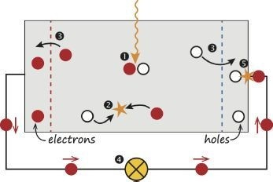

Fig. 5: A very simple solar cell model. (1) Absorption of a photon leads to the generation of an electron-hole pair. (2) Usually, the electrons and holes will recombine. (3) With semipermeable membranes the electrons and the holes can be separated. (4) The separated electrons can be used to drive an electric circuit. (5) After the electrons have passed through the circuit, they will recombine with holes [3].

### 2.1.3. Collection of the photo-generated charge carriers at the terminals of the junction

Finally, the charge carriers are extracted from the solar cells with electrical contacts so that they can perform work in an external circuit (Fig. 5 (4)). The chemical energy of the electronhole pairs is finally converted to electric energy. After the electrons have passed through the circuit, they will recombine with holes at a metal-absorber interface, as illustrated in Figure 5 (5).

**Loss mechanisms**

The two most important loss mechanisms in single bandgap solar cells are the inability to convert photons with energies below the bandgap to electricity and thermalization of photon energies exceeding the bandgap, as illustrated in Figure 4 (b). These two mechanisms alone amount to the loss of about half the incident solar energy in the conversion process. Thus, the maximal energy conversion efficiency of a single- junction solar cell is considerably below the thermodynamic limit. This single bandgap limit was first calculated by Shockley and Queisser in 1961 [3].

## 2.2. PV module operation

PV cell technologies are plentiful and are becoming more widely available each year, but monocrystalline and multicrystalline silicon modules are the most widely used (Figure 6).

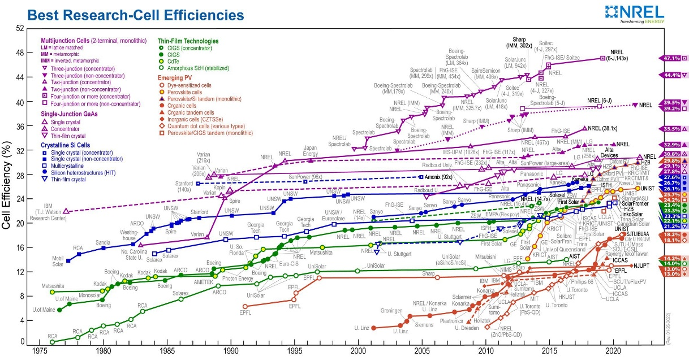

Fig. 6. Best research cell efficiencies [4]

A photovoltaic (PV) cell is a semiconductor-based component that produces electrical power by absorbing light energy and converting it into electrical energy. The average power produced by a PV cell is relatively at 3 watts, so it requires a combination of several cells to produce significant power.

Multicrystalline modules are made of polycrystalline silicon, this is one that crystallized from many single crystals. The cells are usually light blue in color, have a square or rectangular shape, and the edges of the crystals are often visible. This type of cell has a high efficiency, but lower than the single-modules, and a high rate of loss of power at ambient temperatures, but lower than the mono-modules. Multicrystalline modules are also 8-15% cheaper than monocrystalline modules. (Figure 7a). The elements of the monocrystalline solar module are made of large silicon single crystals. It is usually black. This type of module has the highest efficiency and the highest rate of power reduction with increasing ambient temperature. For this reason, efforts should be made to keep modules with crystalline silicon cells cold, or to collect modules from other technologies (Figure 7b).

|  |  |
| --- | --- |
| <https://www.giminija.lt/wp-content/uploads/2017/03/polikristalinis-c-Si_fotoelektrinis_modulis.png>  a) | <https://www.giminija.lt/wp-content/uploads/2017/03/monokristalinis-c-Si_fotoelektrinis_saules_modulis.png>  b) |

Fig. 7. Solar module

A photovoltaic module consists of a group of PV cells mounted on a single panel and connected together to produce combined power (Figure 8a). The typical PV module for a residential system is rectangular in shape and is between 25 and 50 mm thick. PV module power ratings range from less than 50 watts to around 200 watts. Nominal module voltages are 6, 12, 24, or 48 V.

A PV module includes a metal frame, a panel of PV cells, a glass or plastic protective sheet, and an electrical junction box. The metal frame provides support for the module’s components and also a means to mount the module to a flat surface or a mounting rack. The protective sheet of glass or plastic covers the PV cells and protects them against adverse weather, but allows sunlight to pass through to them (Figure 8b). The junction box is a weather-tight enclosure located on the back of the module. It is where the electrical connections from the cells converge, and where the output connection terminals are located (Figure 8c).

|  |  |  |
| --- | --- | --- |
|  |  |  |
| a) | b) | c) |

Fig. 8. PV module components [5]

PV cells are mounted on a panel in symmetric rows and columns. The number of PV cells on a panel varies, but modules with 36 or 72 cells are common. The cells are wired together, typically with each column of cells connected in series to increase the voltage and the columns of series-connected cells connected in parallel to increase the current (Figure 9a).

Both physical and electrical cell arrangement determines a PV module's maximum output. For example, a 36-cell module may have four columns of nine series-connected cells. If each cell outputs 0.6 volt and 2.0 amps, the combination would generate 5.4 volts (9x0.6=5.4) and 8 amps (4x2.0=8) set up in parallel, for a maximum output at 43.2 watts (5.4Vx8A=43.2 watts) (Figure 9b).

|  |  |
| --- | --- |
| a) | b) |

Fig. 9. Cell arrangement determines maximum output [5]

The junction box houses the connection terminals for the module. The series and parallel combination of the cells are connected to these terminals. Typically, there is a positive (+) connection terminal and a negative (-) connection terminal so that the output of the PV module can be connected to other devices. Also, commonly located in the junction box are bypass diodes. The bypass diodes are often wired in parallel with the series strings of PV cells and allow current to flow around or bypass a string of PV cells that may be shaded or damaged. An extra connection terminal allows the bypass diodes to be connected as needed (Figure 10)

|  |  |
| --- | --- |
|  |  |

Fig. 10. Module connections

PV modules are usually mounted and tilled to obtain maximum exposure to sunlight for as long as possible each day. The modules convert the available solar radiation into electrical power, which wires carry from each module to the rest of the system. When there is no light, the modules do not produce power. Combined PV module output voltage and current characteristics are similar to that of individual cells. Like PV cells, connecting PV modules in series increases the potential system voltage while connecting them in parallel increases the potential system current.

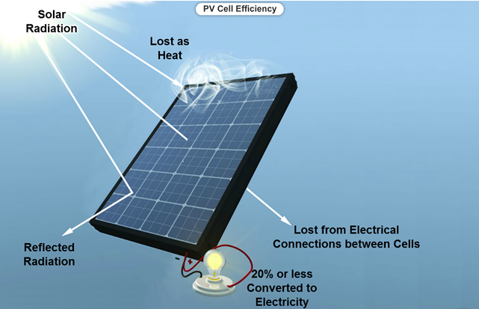

Fig. 11. Typical PV module efficiency [5]

Not all of the solar radiation is converted to electrical potential by a PV cell. Some radiation is reflected, some is converted to heat, and some passes completely through the cell. The efficiency of a typical commercial grade PV module is slightly less than the efficiencies of the individual cells within the module, often due to efficiency loss at the electrical connections. Typical PV module efficiency ranges between 15 and 20 %. Some modules have higher efficiencies, but the improvement often sacrifices durability and lifespan (Figure 11).

### PV Module Safety Rules

Take the following precautions when connecting and disconnecting PV modules to avoid a possible shock.

* Cover PV modules before connecting or disconnecting.
* Use the array disconnect switch to isolate the PV modules from the rest of the circuit.
* Check the PV module connection terminals with a meter to verify that np valtage is present.
* Never work on electrical components alone.
* Use the appropriate tools and measurement devices for the conditions.

PV systems expose workers to electrical shock hazards, burn hazards from the sun and battery chemicals, eye injury due to flying debris and sun exposure, and head or foot injury due to falling objects. These hazards require workers to use the proper personal protection equipment (PPE). The following precautions should be taken to avoid injuries (Figure 12).

* Wear gloves to protect against electrical shock, cuts, burns from hot surfaces and chemical burns.
* Wear UV-rated safety glasses to protect against flying debris and ultraviolet light.
* Wear sunscreen to protect against sunburns.
* Wear a hardhat in a construction environment to protect from falling object.
* Wear safety shoes to protect the feet from injury.

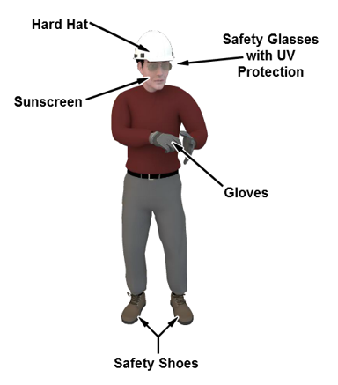 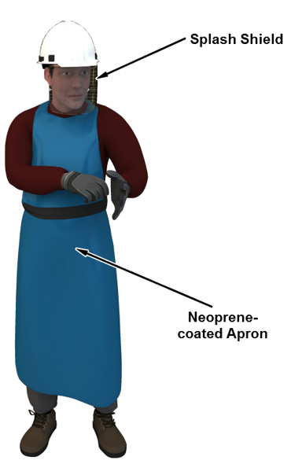

Fig. 12. Personal protection equipment

Some PV system use batteries that contain corrosive acids, which can cause serious chemical burns. The following precautions should be taken to avoid possible chemical burns.

* Wear a neoprene coated apron when handling battery acid to protect against liquid acid splashes.
* Wear a splash shield to protect the face and eye from acid burns.

Some PV installations are made in elevated locations. Take the following precautions to avoid injury due to improper ladder use.

* Ladders should be level and properly secured to prevent unwanted movement.
* Ladders should have at least 1 meter extending above the landing surface.
* Use a ladder with rails made from nonconductive material.
* Avoid using a wet ladder.
* Never walk underneath a ladder.

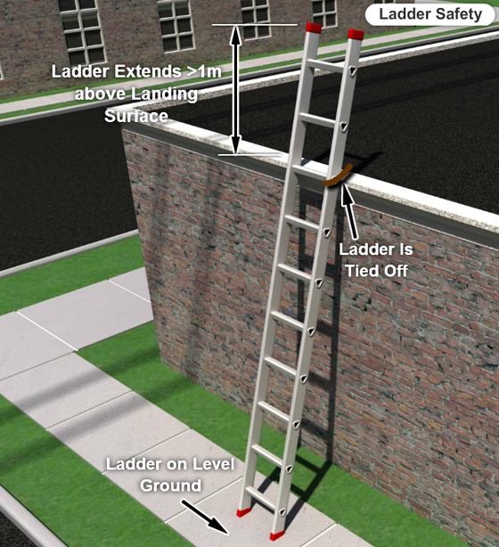 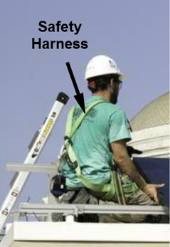

Fig. 13. Height safety

PV modules are often installed in locations such as roofs that present safety hazards due to dangerous heights. The following precautions should be taken to avoid injury due to a fall.

* Wear a climbing harness and makes sure it is properly secured.
* Make note and avoid any possible trip hazards in the work area.
* Do not attempt PV installation in windy conditions. Modules are subject to wind gusts and can push a ladder over.
* Do not perform electrical work in wet conditions water decreases the resistance between the body and ground.

The type of conductors used is often determined by the environment. PV modules are often located in high temperature locations, making it necessary to use conductors that have sufficient temperature ratings, 90°C, for example. Special single-conductor cable labeled as PV wire has become a popular code-approved selection over the past few years.

Once the PV module is connected to the PV system, cover can be removed from the face of the module. The output of the module connections to the system by turning on the disconnect switch or circuit breaker. The PV module continues to supply power to the system as long as sunlight is available and the module is not shaded or disconnected from system.

|  |  |  |  |  |  |  |  |  |  |  |  |  |  |  |  |  |  |  |  |  |  |  |  |  |  |  |  |  |  |  |
| --- | --- | --- | --- | --- | --- | --- | --- | --- | --- | --- | --- | --- | --- | --- | --- | --- | --- | --- | --- | --- | --- | --- | --- | --- | --- | --- | --- | --- | --- | --- |
| Pick the right words and put them in the missing places in the sentence.   |  |  |  |  |  | | --- | --- | --- | --- | --- | | adverse | conductors | diode | electrons | hazard | | asymmetric | maximum | minimum | moderate | N-type | | bypass | negative | output | P-type | parallel | | cells | perpendicular | photovoltaic cell | positive | protons | | clear | radiation | residential | safe | symmetric | | commercial | voltage | watts | wire | components |  1. A(n) (component) is a semiconductor-based component that produces electrical power by absorbing light energy and converting it into electrical energy. 2. PV cells are mounted on a panel in (symmetric) rows and columns. 3. PV modules are usually mounted and tilted so they have (maximum) exposure to sunlight for as long as possible each day. 4. (Adverse) . weather conditions present safety hazards when working on PV systems. 5. The .(output) . of the module connects to the systems by turning on the disconnect switch or circuit breaker. |

### PV characteristics

The current-voltage (I-V) characteristic is the electrical output profile of a PV module and is represented by of a plot of current versus voltage. This plot produces a curve, called an I-V curve, that identifies all possible current-voltage points for a specified solar radiation level and temperature as the load varies. Each point along the curve represents an operating point for a different load. The end points of an I-V curve represent the maximum current and maximum voltage the PV module can produce for specified conditions (Figure 14a).

|  |  |
| --- | --- |
|  |  |
| a) | b) |

Fig. 14. I-V curve

The specific point on the I-V curve at which the product of the voltage and current is at the maximum is called the maximum power point (P-sub-MP). This point is located at the knee of the I-V curve. The voltage at this point is labeled the maximum power voltage (V-sub-MP) and the current is labeled the maximum power current (I-sub-MP). The power values, P-sub-MP, V-sub-MP, and I-sub-MP, are used along with open-circuit voltage (V-sub-OC) and the short-circuit current (I-sub-OC) to rate module performance. These performance ratings are then used to select PV modules for an application (Figure 14b).

The I-V performance curve of a common PV module receiving an irradiance *E* (typical 1000 W/m2) is depicted in the following figure (Figure 15).

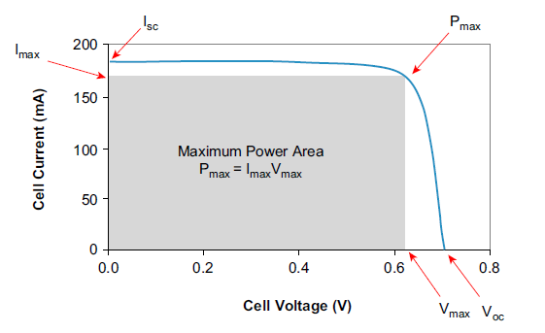

Fig. 15. Solar module I-V characteristic curve [6]

Several characteristic points or values can be distinguished on this curve [6]:

**Short-circuit current, *I*sc:** The current that is obtained from the cell when the voltage at its terminals is 0 V (*V*=0).

**Open circuit voltage, *V*oc**: The voltage for which the current drawn from the cell is zero (*I*=0). If the device is kept in an open circuit, it will self-polarize with a certain voltage that is the largest it can withstand in the generation region, or voltage to open circuit *V*oc. It is the maximum voltage achieved by a solar cell in silicon cells.

**Peak Power, PP**: Because the power is supplied as a DC, the power delivered to the load will be *P=I*V*. There will be an operating point (*IM, VM*) with a voltage value between 0 and *V*oc for which the delivered power is the maximum amount possible.

**Fill Factor, FF**: An indicator of the shape of the characteristic curve and is defined as the peak power (PP) divided by the open circuit voltage (*V*oc) and the short circuit current (***I*sc**).

. (2)

The sharper the characteristic curve of the cell is, the higher the FF will be

$PP=FF{∙I}_{sc}V_{oc}$. (3)

**Energy conversion efficiency,*η*:** The ratio between the maximum power delivered (PP) and the input radiant power to the PV module, calculated as the product of panel area times the reference irradiance (*A*E*).

${}_{el}=\frac{I_{sc}V_{oc}}{A*E }$*.* (4)

PV module efficiency is the ratio of electrical power output to the solar power input. Efficiency describes how effectively a PV module converts solar power into electrical power. A high efficiency results in more solar power being converted into electrical power. A low efficiency means less solar power is converted to electrical power.

The actual efficiency of a PV module can be determined using the PV Module Efficiency Formula.

${}_{el}=\frac{P_{MP}}{E*A}$,

where ${}_{el}$– efficiency (%), $P_{MP}$– maximum power (W), *A* – area (m2), *E* – solar irradiance (W/m2).

The electrical power output of a module is included in the specifications for the module. The power supplied to a PV module is a product of the irradiance and the surface area. Therefore, the maximum output power, the surface area of the PV module, and the solar irradiance must be known to calculate efficiency.

${}_{el}=\frac{P_{MP}}{E*A}=\frac{135}{1100*1.5*0.668}=12.2\%$,

In the example shown, a 1.5 m x 0.668 m PV module with a maximum power output of 135 W has an efficiency of 12.2% when calculated with a solar irradiance of 1100 W/m2.

A high efficiency is an advantage because it allows a PV module to produce more power using less surface area than modules made of cells with a lower efficiency.

The advantages of using less surface area include:

* Lower cost for raw materials
* Reduced area required to mount the module
* Reduced cost for mounting structures
* Higher output per unit area

PV module efficiency is commonly included in the manufacturer's specification data. This value is used by designers to calculate the power output for any given solar irradiance. It can be found using the PV Module Output Power Formula.

$P_{OUT}=*E*A=0.145*1200*1.28=222.72W$,

where $P_{OUT}$– output power at given solar irradiance (W)

For example, the output power of a PV module with a surface area of 1.28 m2 (1580 mm x 808mm) and an efficiency of 14.5% would be calculated for a solar irradiance of 1200 W/m2 to be 222.72 W, as shown.

|  |
| --- |
| Examine the specifications for PV module. What is the efficiency of PV module? |

PV module manufacturers often superimpose a power curve over the I-V curve to show how power varies with load. The power curve starts and ends at zero watts. The voltage at I-sub-SC is zero volts, so no power is produced at that operating point. Likewise, the current at V-sub-OC is zero amps, so no power is produced at that operating point. The power curve increases to a single maximum between V-sub-OC and I-sub-SC. The highest point of the curve corresponds to the maximum power point (P-sub-MP). This is operating point at which the PV module is most efficient. Therefore, PV systems are often designed to keep PV modules operating at the maximum power point as much as possible (Figure 16).

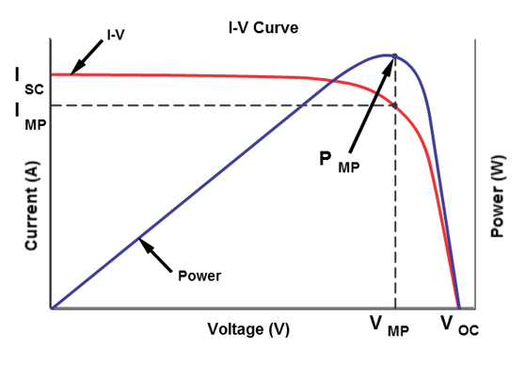

Fig. 16. Most efficient power point

A PV module produces the maximum output voltage, the open-circuit voltage (V-sub-OC), when operating in sunlight without a load connected to the terminals. To measure the open-circuit voltage of a module, first disconnect it from the load and expose it to the solar radiation level specified for the I-V curve. Then, measure the open-circuit voltage across the open-circuit voltage across the terminals of the module with a multimeter. Using the open-circuit voltage measurement and the manufacturer’s I-V curve for the specified solar irradiance, it is possible to reliably determine if the PV module is operating at the specified V-sub-OC. An open-circuit voltage measurement below the V-sub-OC rating for the actual solar energy level indicates a malfunction or damage to the module (Figure 17).

|  |  |
| --- | --- |
|  |  |

Fig. 17. Open-circuit voltage

A PV module produces maximum current or short-circuit current (I-sub-SC) when operating in sunlight with the terminals short-circuited (zero resistance). PV modules differ from other electrical power sources in that they can be short-circuited without causing damage. Since short-circuiting a PV module does not cause damage, it is possible to measure I-sub-SC and compare the reading to an I-V curve to determine if a module is operating within specifications. A short-circuit current measurement that is significantly below the specification level may indicate the module has been damaged (Figure 17). The short-circuit current of a PV module can be measured using either a multimeter or a clamp-on ammeter. With both methods, the load and module are disconnected. The module is exposed to a steady level of solar radiation, the positive and negative terminals are shorted, and the measurement is made (Figure 18).

|  |  |
| --- | --- |
|  |  |

Fig. 18. Multimeters

To use a multimeter, it is placed in the current measuring mode and is connected in series with the PV module terminals. The multimeter reads the current flow through the test probes. This type of measurement is very accurate, but most probe-type meters are limited in the maximum current they can safely measure. Exceeding that limit results in a blown fuse in the multimeter. To use the clamp-on ammeter to measure short-circuit current, the meter’s clamp is placed around the wire that is used to short the PV module’s terminals. This type of measurement is less accurate than using the multimeter because the clamp-on ammeter is less sensitive to small currents. However, it is much safer in high-current conditions.

Measuring the output of a PV module for a specific load and a given level of solar radiation requires measuring the current passing through the load and the voltage applied to the load. This is done to determine if the module is operating within specifications. Using the measuring voltage and current, the operating point is located on the I-V curve that matches the level of solar radiation. Since most manufacturers provide several I-V curves for a module, it is important to choose the correct curve (Figure 19).

|  |  |
| --- | --- |
|  |  |

Fig. 19. I-V curve for different solar radiation level

For example, if the solar radiation level for measurements is 800 W/m2, the I-V curve for that level is selected and the operating point matching the measured values is located. An operating point that does not fall on the I-V curve indicates that there may be a problem with the module, or the wrong curve was selected.

|  |  |  |  |  |  |  |  |  |  |  |  |  |  |  |  |  |  |  |  |  |  |  |  |  |  |  |  |  |  |  |
| --- | --- | --- | --- | --- | --- | --- | --- | --- | --- | --- | --- | --- | --- | --- | --- | --- | --- | --- | --- | --- | --- | --- | --- | --- | --- | --- | --- | --- | --- | --- |
| Pick the right words and put them in the missing places in the sentence.   |  |  |  |  |  | | --- | --- | --- | --- | --- | | above | conductors | I-V | probe-type | terminal | | amps | current | load | protons | below | | bypass | diode | multimeter | residential | V-sub-MP | | cells | electrical | open-circuit | short-circuit | voltage | | clamp-on meter | hazard | P-sub-MP | solar | watts | | components | I-sub-MP | power | specifications | wire |  1. Plotting current versus voltage will give you a(n) …(I-V)… curve. 2. The highest point of a power curve corresponds to the ….(P-sub-MP)….. 3. The …(power)…. curve increases to a single maximum between V-sub-OC and I-sub-SC. 4. A PV module produces the maximum output voltage when no …(load)... is attached to the terminals. 5. Exceeding the maximum current limit can result in a blown fuse in the ….(multimeter). 6. A(n) ...(open-circuit).. . voltage measurement bellow the V-sub-OC rating for the actual solar energy level indicates a malfunction or damage to the module. 7. It is much safer to use a(n) …(clamp-on meter) in high current conditions. 8. A short-circuit measurement that is significantly …(below)… the specification level may indicate damage to the module. |

### Photovoltaic arrays

PV modules are connected as an array to increase the PV system's output voltage and current. The I-V curve of a group of PV modules connected into an array a similar to the graph of a single module, with each connected module extending the PV system's output voltage or current. PV modules are connected in an array using one of two connection types: series connection and parallel connection.

PV modules are connected in series to increase the output voltage. Series-connected modules are called strings. PV modules are connected in series by connecting the positive lead from one module to the negative lead of the next. The unconnected outputs from the modules on the end of the string are the positive and negative string outputs. The output voltage of a string of similar modules is equal to the sum of the voltages available from each module, just like batteries connected in series (Figure 20).

|  |  |
| --- | --- |
|  |  |

Fig. 20. Series and parallel connection

The I-V curve of a string of PV modules appears similar to that of a single module (Figure 21a). Each module in the string increases the voltage, *V*oc produced by the string. However, the string's output current, *I*sc, is the same as that for a single module. The amount of current flowing in series-connected modules is limited to the amount of current that can flow through a single module. A disadvantage of connecting modules in series is that a reduced output power condition in one module reduces the output power of the whole series string. For example, if one module in a string is shaded, the module’s output voltage is reduced and the total current passing through the series string is limited to the amount that can flow through the shaded module.

|  |  |
| --- | --- |
| a) | b) |

Fig. 21. Series and parallel I-V curves

PV modules are connected in parallel to increase the output current. The available output current, *I*sc, is equal to the sum of the individual module currents, just like batteries connected in parallel. Because the currents in parallel - connected modules are additive, the I-V curve of a group of PV modules connected in parallel extends the current, *I*sc, produced by the array. However, the output voltage, *V*oc, is the same as that for a single module (Figure 21b). A characteristic of parallel wiring is that losses in a single module do not affect the other modules. When portal shading occurs on one of the parallel modules, the other modules continue to produce power at their full capacity. However, the total current provided by the parallel modules is reduced. Most arrays, contain a combination of series and parallel-connected modules to produce the voltage and current levers necessary for a PV system. An array’s I-V curve resembles that of the individual modules used in the array, except the array’s curve is extended horizontally and vertically. Each series connection extends the voltage on the horizontal axis of the I-V curve, while each parallel connection extends the current on the vertical axis.

The maximum power voltage and maximum power current of the PV modules used in the array are listed in the manufacturer's specification for the modules. These values should be recorded to use in the voltage, current, and power calculations. Some specification sheets may list maximum power voltage as peak power voltage and maximum power current as peak power current.

Table 1

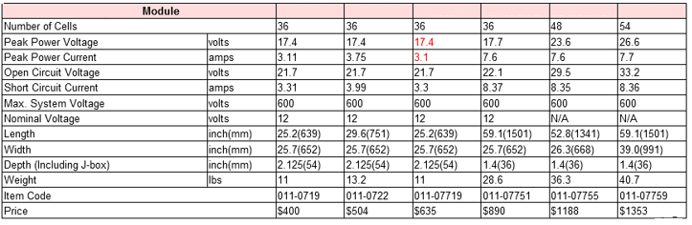

*VMP*- maximum / peak power voltage

*IMP* - maximum / peak power current

Modules are connected in series to increase the voltage available from the system. The maximum power voltage of several modules connected in series is calculated using the formula shown.

*VMPString=NS* VMP*,

where *VMP* - maximum power voltage of a module (V), *NS* - number of modules in the string, *VMPString* - maximum power voltage of a string (V).

For example, if five PV modules with a maximum power voltage of 18 V are connected in series, the maximum power voltage of the string is: *VMPString=NS* VMP*=5*18=90V

The maximum power current for the series string is equal to the maximum power current of a single module in the string.

*IMPString = IMP*,

where *IMP* - maximum power current of a module (A), *IMPstring* - maximum power current of a string (A). For example, if five PV modules with a maximum power current of 3 A are connected in series, the maximum power current of the string is: *IMPString = IMP*=3A.

Therefore, for a string of three modules (table 1, red mark) in series in an array:

*VMPString=NS* VMP=*3*17.4=52.2V

*IMPString = IMP*=3.1A

Strings of modules are connected in parallel to increase the current available from the system. The maximum power current of several series strings connected in parallel is calculated using the formula shown.

*IMPArray=NP* IMPSting= NP* IMP*,

where *IMP* - maximum power current of a module (A), *NP* - number of strings connected in parallel, *IMPString* - maximum power current of a string (A), *IMPArray* - maximum power current of a array (A).

For example, an array consists of four sets of PV module strings connected in parallel, the maximum power voltage of a string is 90 V, and the maximum power current is 3 A.

The maximum power voltage for the array is equal to the maximum power voltage of a single string.

*VMPArray= VMPString*,

where *VMPString* - maximum power voltage of a string (V), *VMPArray* - maximum power voltage of the array (V)

Therefore, continuing the example with modules (table 1, red mark) connected in series in strings of three, an array of five strings connected in parallel has the following maximum power voltage and maximum power current:

*VMPString=NS* VMP*=3*17.4=52.2V,

*IMPString = IMP*=3.1A,

*VMPArray= VMPString*=52.2V,

*IMPArray=NP* IMPSting*=5*3.1=15.5A.

The maximum power output of the array is calculated using the values for the maximum power voltage and maximum power current of the array that have previously been calculated. The maximum array power is calculated using the following formula:

*PMPArray= VMPArray* IMPArray*,

where: *PMPArray, VMPArray, IMPArray* – maximum power (W), voltage (V) and current (A) of the array accordingly.

|  |
| --- |
| Calculate the maximum power voltage, current ant power of PV arrays.  *VMP*=17.9V  *IMP*=3.5A |

Modules in series are connected by attaching a lead from the positive output terminal of one module’s junction box to the negative terminal in another. A series string therefore has two outputs; a positive lead attached to the module on one end of the string and a negative lead attached to the module on the other. This type of connection is called daisy-chaining (Figure 22a).

|  |  |
| --- | --- |
|  |  |
| a) | b) |

Fig.22. Modules wired in series and parallel

The negative lead from each series string connects to a single negative bus in the combiner box. The output of each bus is a larger diameter wire that supplies current to the remainder of the PV system. This also allows any string to be disconnected from the array without affecting the other strings (Figure22b).

Strings of PV modules are connected in parallel using a junction box called a combiner box. The positive lead from each series string connects to an individual circuit protection device, either a fuse or circuit breaker, in the combiner box. The fuse or circuit breaker outputs are then combined in a single positive bus (Figure 23).

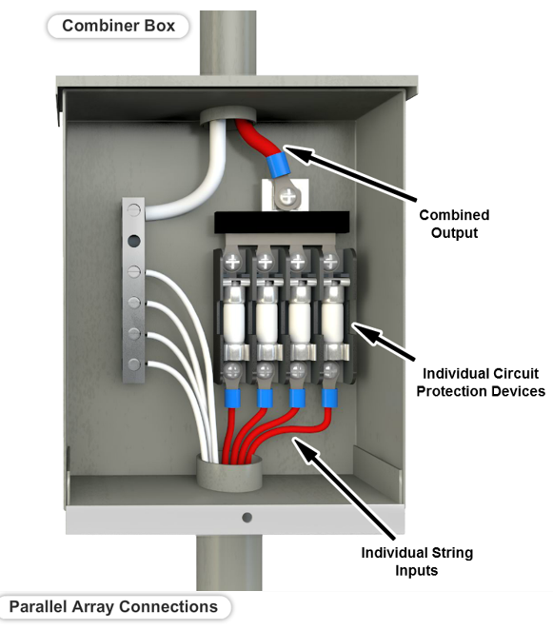

Fig. 23. Combiner box

Combiner boxes are small rectangular junction boxes made of sheet metal or fiberglass. They are usually located near the array, either on the roof or just below where the wiring exits from the array, to reduce wiring and provide easy access to the array's connections (Figure 24a).

|  |  |
| --- | --- |
|  |  |
| a) | b) |

Fig. 24. Combiner box construction

A combiner box may also include a lightning arrestor to protect the system and a disconnect switch to disconnect the entire array from the rest of the system. If a disconnect switch is not provided in the combiner box, one is usually mounted close to the combiner box. Another option is a dead front panel that doesn't expose any electrical connections when it is opened (Figure 24b). Multiple combiner boxes may be necessary if an array contains more series strings than can be connected by one combiner box. Intermediate combiner boxes also be used to combine the outputs from the arrays’ strings, depending on the layout of the PV system.

Combiner boxes are available from several manufacturers, specified by the number of poles in the box. Each pole can connect one series string of PV modules. A smaller combiner box may only combine two to four strings. Larger combiner boxes can combine 16 or more series strings of PV modules. Most combiner boxes are rated for a maximum operating voltage of at least 600V.

The same current flows through each PV module in a series string during normal operation. A partially shaded module or one with damaged cells cannot supply the same current as the others in the string. The shaded module tries to pass more current than its short circuit current, which has been lowered due to the shading. This causes the module to act as a load, absorbing rather than generating power (Figure 25).

|  |  |
| --- | --- |
|  |  |

Fig. 25. Shaded modules

A bypass diode is a diode placed in parallel with a PV module in a series string to minimize the effect that partial module shading or cell damage has on the rest of the PV array. It allows current to flow around a shaded or damaged module. The disadvantage is that the string operates at a lower voltage when one or more modules are bypassed (Figure 26). A bypass diode switches between two conditions: reverse-biased and forward-biased. A diode is reverse-biased when there is a negative voltage at the anode relative to the cathode. Like an open switch, no current flows through a reverse-biased diode. Bypass diodes are reverse-biased when all modules are operating properly because of the polarity because of the voltage generated by the module. Therefore, the bypass diode has no effect on the output of the array (Figure 26).

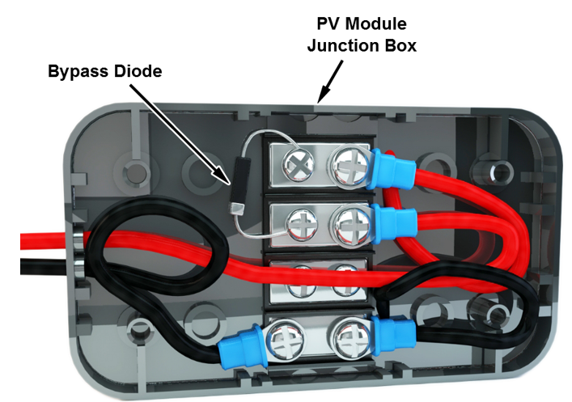

Fig. 26. Bypass diode

A diode is forward-biased when there is a positive voltage at the diode’s anode relative to cathode. A forward-biased diode is similar to a closed switch. Shaded module acts like a resistor, dropping voltage instead of generating voltage. This causes the voltage across the module to swap polarities and causes the bypass diode to become forward-biased (Figure 27).

|  |  |
| --- | --- |
|  |  |

Fig. 27. Bypass diode biasing

When is diode is forward-biased, current from the other modules flows through the bypass diode instead of through the higher resistance PV module. The voltage drop across the shaded module is limited to the forward-bias voltage of the diode, which is approximately 0.7 V, depending on the type of diode. This reduces the output voltage of the string.

|  |  |  |  |  |  |  |  |  |  |  |  |  |  |  |  |  |  |  |  |  |  |  |  |  |  |  |  |  |  |  |
| --- | --- | --- | --- | --- | --- | --- | --- | --- | --- | --- | --- | --- | --- | --- | --- | --- | --- | --- | --- | --- | --- | --- | --- | --- | --- | --- | --- | --- | --- | --- |
| Pick the right words and put them in the missing places in the sentence.   |  |  |  |  |  | | --- | --- | --- | --- | --- | | amp | cathode | I-V curve | polarity | series | | anode | circuit breaker | leads | poles | shading | | array | closed | lightning arrestor | resistor | single-acting | | battery | combiner box | module | rods | strings | | bypass diode | current | opened | ropes | voltage | | capacity | fuse | parallel | selector | volts |  1. Placing a(n) …(bypass diode).. in parallel with a PV module in a series string allows current to flow around a shaded or damaged module. 2. PV modules are connected in ...(parallel).. to increase the output current. 3. Strings of PV modules are connected in parallel using a junction box called a(n) ..(combiner box) . 4. The positive lead from each series string connects to either a circuit breaker or ..(fuse) . 5. A forward-biased diode is similar to a(n) ..(closed).. switch. 6. Commercial combiner boxes are specified by the number of ..(poles).. that may be combined in the box. |

High ambient temperatures around a PV module cause a 10-20% reduction in output voltage. Reduced voltage results in an overall decrease in output power and efficiency. A graph (Figure 28a) of current versus voltage shows that a PV module operates more efficiently at lower temperatures. Therefore, PV modules and arrays should be installed in environments that keep them as cool as possible. PV installation sites that provide a good solar resource, such as in a desert, are often subjected to high ambient temperatures, from 50°C to 75°C. When installing PV modules in locations with high ambient temperatures, the modules must be installed in a manner that provides good air flow around the module to reduce the effects of the high temperatures.

The reduction of the PV module performance with increasing temperature, is given by (5) formula which represents the traditional linear expression for the PV electrical efficiency.

${}_{el}={}_{0,el}(1-(T_{c}-T_{ref}))$, (5)

where *Tc* is PV cell temperature, *Tref* is reference temperature and *β* is the coefficient of temperature. The value of *β* is 0.0045 °C-1. *η*0,el and *β* are normally given by the PV manufacturer.

|  |  |
| --- | --- |
| a) | b) |

Fig. 28. Relationship between ambient temperature, solar irradiance, output current and power

Wind can also affect the electrical output of a PV module. Wind speed, along with ambient temperature, affect the PV cell temperature, which is the internal temperature at the p-n junction of the cell. Higher wind speeds reduce the cell temperature, increasing the PV module's efficiency. PV modules should be mounted so that air can circulate freely around them, keeping the modules cool and increasing efficiency.

Solar irradiance, solar radiation per unit area, is the single most important environmental factor that affects the output of a PV module. The magnitude of solar irradiance at the surface of the Earth changes at different times throughout the day. During the night, solar irradiance is zero. As the sun rises, solar irradiance increases, reaching a peak around noon. Solar irradiance begins to decrease in the afternoon and continues to decrease until sunset. Therefore, the output of a PV module is the greatest during the middle of the day when the solar irradiance is near its peak. While changes in solar irradiance have little effect on the output voltage of a PV module, output current is significantly affected. In fact, the output current, and therefore output power, increase proportionally to an increase in solar irradiation. Therefore, a PV module produces the most power when solar irradiance is at its highest level.

The relationship between solar irradiance, output current, and output power is used in the following formulas to determine short circuit current, maximum power current, and maximum power for a PV module.

The short-circuit current for a PV module at a given solar irradiance is calculated using the Short-Circuit Current Formula.

$I_{SC2}=\frac{E_{2}}{E_{1}}*I_{SC1}$ = $\frac{500}{1000}*5=2.5$ A

where *E*1 – solar irradiance 1 (W/m2), – short circuit current at solar irradiance 1 (A), *E*2 – solar irradiance 2 (W/m2), – short circuit current at solar irradiance 2 (A)

For example, a PV module has a rated short-circuit current of 5 amps at a solar irradiance of 1000W/m2. The short circuit current at a solar irradiance of 500 W/m2 is calculated to be 2.5 amps, as shown.

The maximum power current for a PV module at a given solar irradiance is calculated using the Maximum Power Current Formula.

$I_{MP2}=\frac{E_{2}}{E_{1}}*I_{MP1}$ = $\frac{800}{1200}*8=5.3$ A

where *E*1 – solar irradiance 1 (W/m2), – maximum power current at solar irradiance 1 (A), *E*2 – solar irradiance 2 (W/m2), – maximum power current at solar irradiance 2 (A)

For example, a PV module has a rated maximum power current of 8 amps at a solar irradiance of 1200 W/m2. The maximum power current at a solar irradiance of 800 W/m2 is calculated to be 5.3 A, as shown.

The maximum power for a PV module at a given solar irradiance is calculated using the Maximum Power Formula.

$P_{MP2}=\frac{E_{2}}{E_{1}}*P_{MP1}$ = $\frac{650}{1000}*150=97.5$ W

where *E*1 – solar irradiance 1 (W/m2), – maximum power at solar irradiance 1 (W), *E*2 – solar irradiance 2 (W/m2), – maximum power at solar irradiance 2 (W)

For example, a PV module has a rated maximum power of 150 watts at a solar irradiance of 1000W/m2. The maximum power at a solar irradiance of 650 W/m2 is calculated to be 97.5W, as shown.

|  |
| --- |
| Calculate short-circuit current for a PV module at a solar irradiance of 700 W/m2, the maximum power current for a PV module at a solar irradiance of 550 W/m2, the maximum power for a PV module at a solar irradiance of 800 W/m2 based on the manufacturer's data. |

## Solar PV system

### Charge controlled PV system

A charge-controlled PV system is typically a standalone system that operates DC loads (Figure 29). It is the most common type of DC PV system and is often used in remote locations where utility generated power is either unavailable or too costly due to the price of extending power lines. These systems power DC appliances such as TVs, stereos and fluorescent lights in homes or in recreational vehicles or boats. Charge-controlled PV systems are also used extensively in applications that do not require a lot of power, such as solar traffic lights and information displays, and in more remote locations for solar lighting and pump systems.

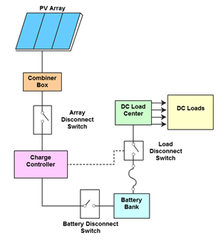

Fig. 29. Charge – controlled PV system

A charge controlled solar PV system may include several components:

* PV array - the PV array supplies power to the DC loads and any batteries connected to the system.
* Combiner box - the combiner box combines the power from the array’s series strings and passes it to the charge controller.
* Charge controller - a charge controller controls the amount of charge supplied to the batteries to protect them from overcharging or completely discharged.
* DC load center - the DC load center contains fuses or breakers to control the distribution of power to the loads.
* DC loads - the DC loads of the charge-controlled system may include DC appliances solar lighting, pumps, or other DC loads.
* Batteries - the batteries store the power produced by the PV array and supply the power to DC loads when the PV array is not producing power, for example at nighttime.

A complete charge-controlled PV system requires a number of additional components to deliver the power from the PV array to the loads.

* Electrical equipment - the electrical equipment includes the electrical wiring, conduit, fuses, breakers, disconnect switches, junction boxes, meters and other components needed to operate the system.
* Mounting hardware - the mounting hardware is the racks and hardwire required to mount the PV panels and other components of the system.

|  |  |
| --- | --- |
|  |  |
| a) | b) |

Fig. 30. Charge controller

The status of a PV system may be displayed on the charge controller's LCD screen during operation. For example, the Morningstar SunSaver MPPT status can be displayed on the remote meter when the charge controller is operating. The Status screen displays the following information (Figure 30a):

* The input voltage and current from the PV array (IN).
* The output voltage and current used to charge the batteries (OUT).
* The amount of current used by the load.
* The accumulated kilowatt hours of energy produced by the system.

The Morningstar SunSaver MPPT charge controller operates (Figure 30b) in one of several modes. The mode of operation changes during the day based on the PV array output and battery system state of charge. The SunSaver MPPT charge controller’s mode is conveyed by a series of LED indicators (Figure 31).

* Night Mode - the charge controller enters the night mode when the PV array voltage is less than the battery voltage or the available charge current is below the minimum required to charge the battery bank. The controller disconnects the battery from the system and waits for the PV array to begin providing more voltage and current. In this mode, the charge controller flickers an LED status light briefly every five seconds.
* MPPT Bulk Mode - The charge controller enters the MPPT Bulk mode after the maximum power point has been determined and the PV array load has been adjusted to operate at that point. The charge controller charges the batteries in a bulk charging mode until the battery voltage reaches the absorb or float voltage setpoints. In bulk-charge mode, the SunSaver charge controller displays a steady green status light that flickers off briefly every five seconds.

|  |  |  |
| --- | --- | --- |
|  |  |  |
| Night Mode | MPPT Bulk Mode | Absorb Mode |
|  |  |  |
| Float Mode | Battery Full Mode | Equalize Charge |

Fig. 31. Charge controller modes

* Absorb Mode - the charge controller enters the Absorb mode after the battery voltage has reached the absorb voltage setpoint. The charge controller keeps the battery voltage at the absorb voltage setpoint. The setpoint is modified by battery temperature compensation if the charge controller supports that function. In the absorb mode, the SunSaver charge controller flashes a green status light once per second.
* Float Mode - the charge controller enters Float mode after the battery voltage level reaches the float setpoint. This occurs after an absorption charge stage or after the voltage level of a full battery falls back below the float setpoint. The charge controller attempts to keep the batteries at the float voltage setpoint during this Stage. If it cannot, the system returns to bulk charge mode. In the float mode, the SunSaver charge controller flashes a status light slowly, once every two seconds.
* Battery Full Mode - the SunSaver charge controller displays a solid green status light when the battery is nearly full. It then waits for the battery voltage to fall below the float voltage setpoint before continuing with the float stage.
* Equalize Charge - an equalize charge purposely overcharges a battery. This process helps maintain the battery's efficiency. The charge controller will enter the equalize charge mode periodically or when it identifies that the battery was discharged too low the previous night. Equalization is only used for flooded batteries. When in the equalization mode, the SunSaver charge controller flickers a green status light quickly, about two flashes per second.

|  |  |  |  |  |  |  |  |  |  |  |  |  |  |  |  |  |  |  |  |  |  |  |  |  |  |  |  |  |  |  |
| --- | --- | --- | --- | --- | --- | --- | --- | --- | --- | --- | --- | --- | --- | --- | --- | --- | --- | --- | --- | --- | --- | --- | --- | --- | --- | --- | --- | --- | --- | --- |
| Pick the right words and put them in the missing places in the sentence.   |  |  |  |  |  | | --- | --- | --- | --- | --- | | MPPT bulk mode | charge acceptance | DC | MPPT | power | | DC-DC converter | charge controller | DC load center | absorb mode | Pv array | | active charging stage | charge-controlled | AC | multistage | adjusts | | regulation setpoints | charging | do | night mode | standalone | | charging functions | battery bank | float charging | overcharge | temperature | | battery manufacturer’s | configured | higher | overcharging | wakeup mode |  1. A charge-controlled PV system is typically a(n) ..( standalone).. system that operates DC loads. 2. A charge controlled PV system is the most common type of ..(DC).. PV system. 3. Charge-controlled PV systems are also used extensively in applications that do not require a lot of ..(power).., such as solar traffic lights and information displays, and in more remote locations for solar lighting and pump systems. 4. The charge controller enters the ..(night mode).. when the PV array voltage is less than the battery voltage or the available charge current is below the minimum required to charge the battery bank. 5. The charge controller enters the ..(MPPT bulk mode).. after the maximum power point has been determined and the PV array load has been adjusted to operate at that point. |

### An inverter

An inverter is an electronic device that converts DC power into AC power for standard AC loads. Inverters are used with green power technologies such as solar PV systems and wind turbines. An inverter can produce one of several output waveforms, depending upon its design. The output waveform type is important because it affects overall inverter efficiency and it may prevent the inverter from being connected to the electrical grid.

Three common voltage output waveforms produced by inverters used in PV systems include (Figure32):

* Square Wave Output.
* Modified Square Wave Output.
* Pulse-Width Modulated (PWM) Output

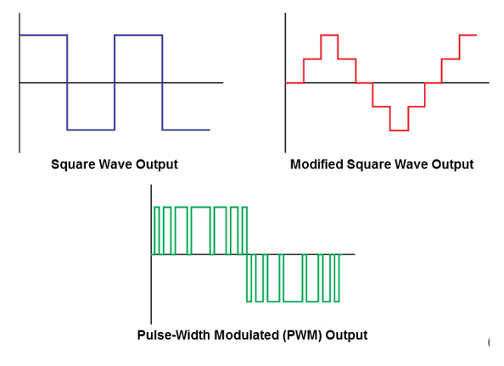

Fig. 32. Waveforms types produced by inverters

The square wave output is the simplest and lowest cost output for a PV inverter. The square wave voltage output has a fixed amplitude and duration for each half-cycle. The current waveform produced by the square wave output does not approximate a sine wave. Therefore, inverters with this type of output cannot be connected to the electrical grid (Figure 33a).

|  |  |
| --- | --- |
|  |  |
| a) | b) |

Fig.33. Square wave output

This approach was used initially for PV inverters but was quickly abandoned with the development of outputs that more closely resemble the sine wave. Square wave outputs are the least efficient of the three and can damage loads due to overheating. Square wave producing inverters can be used in a stand-alone system to power resistive loads, but should not be used in systems with inductive loads such as motors (Figure 33b).

The modified square wave output, also called a modified sine wave or quasi sine wave output, costs more to create than the square wave. However, it produces a current waveform that more closely resembles a pure sine wave, which results in less adverse effects on the loads.

The modified square wave voltage output is created by adjusting the amplitude and duration of the pulses for each cycle. If the duration is increased, the amplitude is reduced to maintain the desired current waveform (Figure 34a). If the duration is decreased, the amplitude is increased to maintain the desired current waveform.

|  |  |
| --- | --- |
|  |  |
| a) | b) |

Fig. 34. Modified square wave output

PV inverters that provide a modified square wave output are more efficient than ones that provide a square wave output. They are a popular choice for Stand-alone PV systems and can be connected to the electrical grid using the proper power conditioning equipment. Some modified square wave inverters combine multiple square wave stages in parallel to create a multi-stepped modified square wave. This multi-stepped waveform produces a current waveform that is even closer to a true sine wave than a single-stage modified square wave inverter can produce (Figure 34b). The multi-stepped approach results in better efficiency but increases the initial cost of the inverter. Inverters with this type of output are used for both standalone and grid-tie applications.

The pulse-width modulated, or PWM, voltage output is the most complex and costly of the waveforms to produce because of the required technology. However, the pulsed voltage output results in a current waveform that is closest to a pure sine wave. For this reason, PV inverters with PWM output are referred to as sine wave inverters (Figure 35). The PWM output is created by producing several pulses during a cycle. During each half cycle, the pulses follow a pattern of narrow to wide to narrow. This pattern creates a sine-wave current waveform. Inverters that create a PWM output can also adjust the frequency of the output, which means they can be used with 50 Hz or 60 Hz electrical grids.

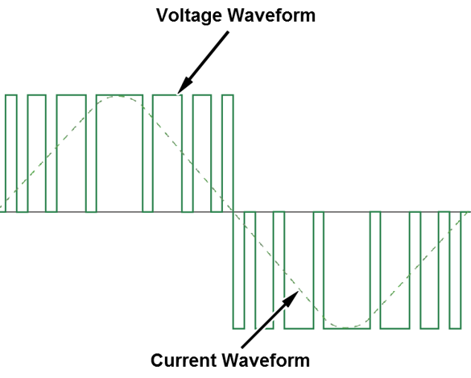

Fig. 35. Pulse-width modulated (PWM) output

PV inverters that provide a PWM output have the highest efficiency. PWM is the overwhelming choice for grid-connected PV inverters because they can be connected directly to the utility grid without extra power conditioning.

Often, PV inverters are categorized according to the system in which they are installed. Some PV systems do not connect to the electrical grid while others do. Therefore, there are inverters designed for both systems.

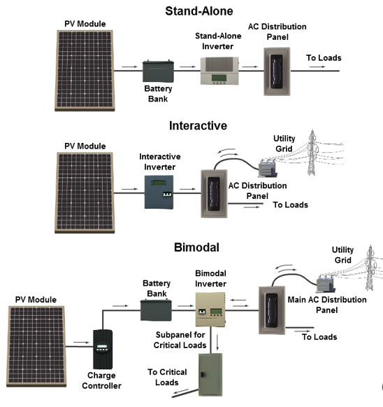

Fig.36. PV inverter types

Three basic types of PV inverters are (Figure 36):

* Stand-Alone Inverters

Inverters used in stand-alone PV systems are referred to as stand-alone inverters. Stand-alone inverters are not designed to connect to the electrical grid. Instead, they are designed to provide AC power to loads at a specific location.

* Interactive Inverters

Inverters designed to connect to the electrical grid are called interactive inverters. An interactive PV inverter, also called a grid-connected or grid-tied inverter, converts DC power directly from the PV modules into AC that can be used by AC loads at the site or supplied to the utility grid. Interactive inverters provide a PWM Output, which produces a pure sine wave current waveform that matches the grid. This feature eliminates the need for extra power conditioning equipment.

* Bimodal Inverters

Bimodal inverters are interactive inverters that can operate in two different modes. In the stand-alone mode, the inverter operates like a standalone inverter and is not connected to the electrical grid. The inverter receives DC power from the battery bank and supplies AC power to loads connected to the inverter. In the interactive mode, the inverter connects to the electrical grid. The inverter supplies AC power to loads connected to it and supplies power to the grid when conditions warrant. Bimodal inverters supply a PWM output just like standard interactive inverters, which allows them to connect to the grid.

A stand-alone inverter converts the DC power from batteries, which use PV modules to keep them charged, to the required AC power for the loads. The inverter uses solid-state devices such as silicon-controlled rectifiers (SCRs) or transistors to create the AC output.

A stand-alone PV system operates independently of the electrical grid. A Stand-alone system uses a battery bank to provide DC power directly to a standalone inverter. The PV modules do not supply power to the inverter. The sole purpose of the PV modules in a standalone system is to charge the battery as long as there is sufficient light.

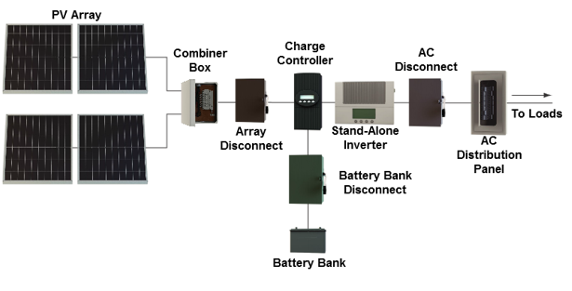

Fig. 37. Stand-alone system

If there is insufficient light for the PV modules to charge the batteries, the stand-alone inverter shuts down after the batteries have discharged to the minimum allowable level unless there is a secondary source, such as a generator or wind turbine, to charge the batteries. The output of the Stand-alone inverter is connected to AC loads through distribution panel. There are no connections to the electrical grid. Stand-alone systems are popular in remote locations where access to the electrical grid is limited or non-existent (Figure 37).

### Batteries

PV systems produce energy and store surplus energy in batteries for use when there is insufficient sunlight. Without a battery, a PV system could only provide electrical power when there is sunlight. Batteries release electrical energy when there is an electrical path, or circuit, linking its outputs. Terminals provide the physical outputs of a battery. Most batteries connect to the circuit by insulated conductors fastened to screw or bolt terminals.

A battery stores electrical energy in the form of chemical bonds. The battery releases energy during a chemical reaction between electrolytes and metal electrodes inside compartments called cells. Each cell contains electrolyte and is divided into two sections by a membrane. One section contains a positive electrode while the other section contains a negative electrode. The chemical reaction between the electrodes and the electrolyte produces a voltage between the electrodes (Figure38a).

|  |  |
| --- | --- |
|  |  |
| a) | b) |

Fig. 38. Battery basics

Most batteries consist of a combination of cells connected in series, so the potential of the cells add together. For example, a 6-volt battery may have three 2-volt cells connected in series, while a 12-volt battery would have six 2- volt cells. Typical nominal voltage ratings for a solar battery are six, eight, or twelve volts (Figure 38b).

Terminals on the battery are marked positive or negative to indicate the polarity. Polarity determines the direction of current flow. The negative terminal is connected to an electrode that reacts with the electrolyte to produce a surplus of electrons. The positive terminal is connected to an electrode that reacts with electrolyte to produce a shortage of electrons. If an electrical path exists between the terminals, currents flows between them (Figure 38a).

When connected to a load, batteries release energy through a process of converting chemical energy into electrical energy reducing the amount of charge stored in the battery. This process is called battery discharging. There are several factors to consider concerning battery discharging:

* Solar Battery Cycles

In a typical PV system, solar batteries charge by absorbing surplus solar energy during the day and discharge by releasing energy at night. This process is called a cycle. The cycle allows for a supply of energy when there is insufficient sunlight. Solar batteries are drained and recharged daily. Deep cycle batteries are designed to operate in this punishing manner. Lead-acid batteries are a popular choice for solar batteries.

* Voltage Drop During Discharge Excessive Discharge

Table 2

|  |  |  |
| --- | --- | --- |
| Nominal voltage | Percent of charge remaining in battery | Note |
| 13.0-12.6 V | 100% | Fully charged |
| 12.3-12.1 V | 75% | Auto battery limit |
| 11.6-11.3 V | 50% |  |
| 10.9-10.6 V | 25% | Deep cycle battery limit |
| Below 10.6 V | Near 0% | Potentially damaged |

A fully charged six-cell solar battery produces between 12.6 and 13 volts. However, as the battery discharges, the output voltage slowly declines. The decline in voltage changes in a predictable way as the charge is released, so the amount of charge in a battery can be determined by measuring the voltage. The level of charge and output voltage of unloaded six-cell solar batteries are related, as shown in the table 2.

* Excessive discharge

All batteries have a discharge limit, and exceeding the limit is destructive. Electrodes are material on a grid, farmed to make a plate. The electrodes dissolve in the discharge process. If the electrodes are stripped too deeply, recharging results in deformed electrodes. Additional losses result from material that is not recoverable.

* Safe Discharge Limit

Battery voltage changes with the remaining charge in a battery. From a full charge down to 25% charge, the voltage decreases steadily from 13 to 10.6 volts. However, below 25%, the battery voltage tends to fall rapidly, making the remaining charge difficult to determine. Operation below 20% charge is usually destructive, even for deep discharge batteries. A voltage less than 10 volts indicates a battery is damaged from being overly discharged.

A battery without a path between terminals maintains a constant voltage called open-circuit voltage. It is a product of the electrodes reacting to the electrolyte. The negative electrode loses positively charged ions, resulting in an accumulated negative charge. The positive electrode absorbs positively charged ions to gain charge. The electrodes react until the voltage opposing the chemical reaction reaches equilibrium. This balance of charge and force is called steady-state.

When battery terminals are connected by an electrical path, the battery releases energy. When a load is connected to a battery, the chemical reaction between the electrodes and the electrolyte continues until all the reactive material is consumed or until the circuit is opened. If the electrical connection is broken, the reaction stops and the battery returns to steady-state condition.

Some batteries, such as solar batteries, can be charged, or recharged, by forcing the chemicals that reacted during discharge into their original condition by applying power to the battery in the opposite polarity.

|  |  |
| --- | --- |
|  |  |
| a) | b) |

Fig. 39. Lead acid solar battery

Most solar batteries are the lead-acid type with three to six cells. Each cell contains two types of metal, lead and lead dioxide, separated by the barrier. The metal is formed into slabs called plates. Both plates are submerged in slightly diluted sulfuric acid, which serves as the electrolyte (Figure 39a).

The lead becomes negatively charged when it reacts with the sulfuric acid and electrons are released. The lead dioxide becomes positively charged when it reacts with the sulfuric acid, and electrons are absorbed. This creates an electrical potential (voltage) across the plates (Figure 39b).

Solar batteries are available with a variety of materials. However, most solar batteries are the wet-cell type, meaning one of the key elements in the battery is a liquid acid. Each wet cell has two compartments, called half-cells, which are divided by a porous membrane. In this type of battery, each half-cell has one or more plates immersed in the acid. The plates are usually made of some type of reactive metal, which is formed onto a frame called the grid. The reactive metal dissolves, but the grid does not. The acid is an electrolyte solution, which allows the transfer of charged particles called ions through the membrane divider.

Terminals on the opposing sides of the half cells provide the entry and exit points for electrons to flow through a circuit. Batteries with multiple cells have terminals located at opposing ends of the series. These are the positive (+) and negative (-) connection terminals. Inside a multiple cell battery, cells connect to each other by intercellular connectors. Each negative electrode is connected by a conductor through the cell wall to the positive electrode of the adjacent cell. Terminals attach to the positive and negative electrodes of the end cells.

Adequate precautions should be taken when handling or servicing batteries because they present several serious dangers. A battery can deliver a lethal level of current. The following precautions should be taken to avoid shock when working with solar batteries:

* Never work on electrical components alone. Someone should be present to remove power and provide assistance in the event of an accident.
* Use the appropriate tools and measurement devices for the conditions.
* Never work on an energized electrical system. Verify that power has been shut off completely before beginning work.
* Open the circuit before connecting a battery. This is usually done with a disconnect switch of circuit breaker.
* Never make contact with both terminals of a battery at the same time to avoid serious injury or death.

Solar batteries expose workers to burn hazards due to acids. The following precautions should be taken to avoid this type of injury:

* Wear gloves that protect against chemical burns and electrical shock. Battery acid can cause severe burns.
* Always keep batteries upright to avoid leaks and spills of acid.
* Wear a fact shield and acid resistant apron when adding electrolyte to a battery.
* Do not overfill battery cells with electrolyte. Overfilling can result in excessive gassing which increases the possibility of explosion.

Contact between battery acid and some kinds of plastics, polyester fiberglass, and exotic paints can result in toxic fumes. The following precautions should be taken to avoid injury due to toxic fumes:

* Locate solar batteries in a well-ventilated location when possible.
* Wear a respirator where batteries are installed in poorly ventilated locations.
* Replace leaking batteries.

One indicator often used to determine the remaining charge in a battery is the open-circuit voltage (Figure 40). This is battery voltage measured at the battery's terminals with no circuit connected. The voltage of a battery changes when active, and varies with rate of discharge. The open-circuit voltage of a battery represents the charge of a battery in the inactive or steady-state condition. A fully charged 12-volt battery has a nominal potential of 12.6 to 13.0 volts, while a battery nearing maximum discharge has a nominal potential between 10.8 and 11 volts. The battery must be disconnected from a circuit before measuring the open-circuit voltage because the voltage at the terminals of a battery changes during discharge. Voltage measurements made while discharging a battery cannot be used to accurately estimate the level of battery charge. The circuit should be opened somewhere other than the battery terminals to avoid arcing near the battery vents.

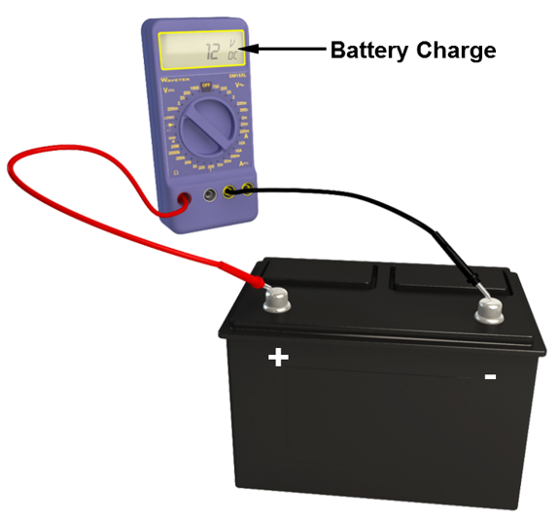

Fig. 40. Open-circuit voltage measurement

Prior to making the measuring, identify the positive and negative battery terminals. The positive terminal may be red, or may marked with a plus sign (+). The negative terminal may be black, or may be marked with a negative sign (-). Match the red test probe to the positive terminal. Take the measurement using a voltmeter with the test probes contacting the terminals. Use the measurement to estimate battery charge.

A battery's open-circuit voltage measurement should be between 10 and 13 volts, unless the battery has malfunctioned. The battery's remaining charge can be estimated from the measured voltage using a straight-line scale with 13 volts representing 100% charge and 10.8 volts representing 25% charge. For example, 12 volts would represent roughly 50% charge remaining. If the measured open-circuit voltage is below 10 volts, the battery should be recharged or replaced (Figure 41).

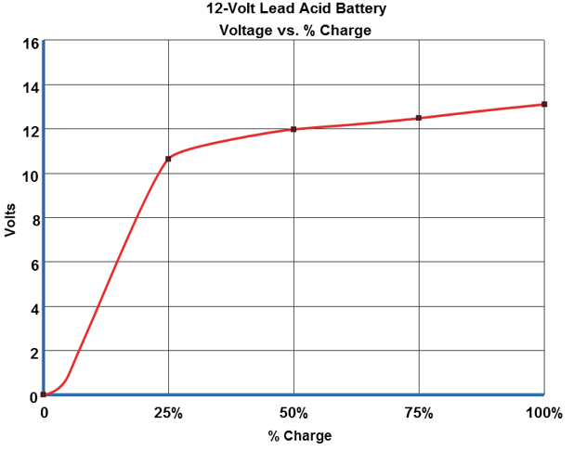

Fig. 41. Voltage vs.% charge

|  |  |  |  |  |  |  |  |  |  |  |  |  |  |  |  |  |  |  |  |  |  |  |  |  |  |  |  |  |  |  |
| --- | --- | --- | --- | --- | --- | --- | --- | --- | --- | --- | --- | --- | --- | --- | --- | --- | --- | --- | --- | --- | --- | --- | --- | --- | --- | --- | --- | --- | --- | --- |
| Pick the right words and put them in the missing places in the sentence.   |  |  |  |  |  | | --- | --- | --- | --- | --- | | capacity | cutoff voltage | gasses | polarity | SOC | | captive electrolyte | disconnect | gauge | power | specifications | | charge | DOD | lead dioxide | primary | stationary | | chemicals bonds | effective power | lead-acid | secondary | terminals | | circuit | electrical energy | open | self-discharge | toxic fumes | | current | electrolyte | parallel | series | traction |  1. ..(Terminals).. provide the physical outputs of a battery. 2. A battery stores electrical energy in the form of ..( chemicals bonds).. . 3. Terminals on the battery are marked positive or negative to indicate the ..(polarity).. . 4. Do not overfill battery cells with ..( electrolyte).. . |

Battery capacity is expressed several ways, the most common being the combination of the level of current in amperes it sustains at the operating voltage and the length of time in hours it sustains the current. The milliamp-hour (mAh) is a common unit of capacity for smaller batteries. Large batteries are rated in ampere-hours (Ah).

$C_{B}=I_{B}*T_{D}$,

where $C_{B}$– battery capacity (Ah), $T_{D}$- complete discharge time (h), $I_{B}$– current discharged (A). As an example, a 12-volt solar battery supplies 60 amps for 5 hours. The battery, therefore, has a capacity of 300 Ah. This size and rate of discharge is roughly the equivalent to the demand on a typical PV system supplying power to a greenhouse.

$P_{B}=V_{B}*I_{B}$,

where $P_{B}$– power (W), $V_{B}$- voltage (V), $I_{B}$– current discharged (A). Battery capacity is also expressed as units of power. Since the voltage of a discharging battery is relatively constant, the power rating is similar to the energy rating, the only difference being the voltage is factored into the rating. The watt is a common unit of power, and the watt-hour (Wh) is a common unit of energy.

$C_{B}=P_{B}*T_{B}$,

where $P_{B}$– power (W), $T_{B}$- time (h), $C_{B}$– battery capacity (Wh). For example, a 12-volt solar battery supplying 25 amps to a load delivers 300 watts of power. If the battery sustains the power for seven hours, the capacity required would be 2100 Wh.

Battery capacity is calculated directly as the product of the average current and the time for complete discharge of a fully charged battery. As an example, if a fully charged battery is fully discharged after it delivers 3 amps of current for 2 hours, the capacity of the battery is said to be 6 Ah.

The capacity of a battery is also expressed in percentage. The percentage is the portion of remaining charge to the battery's maximum possible charge. The percent of charge removed from a fully charged battery is calculated as shown.

$C_{D}=\frac{I_{B}*T_{B}}{C_{B}}$,

where $C_{D}$- percent of discharged capacity (%). As an example, if a fully charged battery with a 100 Ah capacity is discharged at 3 amps for 5 hours, the percentage of charge released would be calculated as shown. That would mean the percentage of charge remaining would be 85%.

The amount of energy a battery holds and discharges varies by how it is used. Factors that impact the available energy include the discharge rate, level of remaining charge, and physical changes within the battery resulting from the discharging process. In PV systems, the energy demand is usually low for prolonged periods, meaning a slow discharge. The low discharge rate improves the efficiency of the battery resulting in more total energy released (Figure 42).

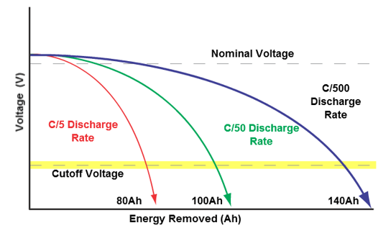

Fig. 42. Variables in charging and discharging a Battery

Several terms are used to describe the amount of energy remaining in a battery. One term is the state of charge (SOC), which is the percentage of energy remaining in a battery compared to the energy in a fully charged battery. Therefore, the SOC of a completely discharged battery is 0%, and the SOC of a half-charged battery is 50% (Figure 43).

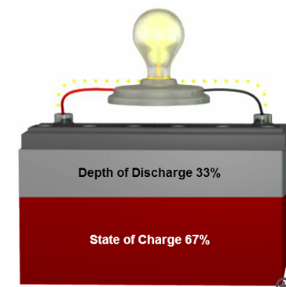

Fig. 43. State of charge

$SOC=\frac{C_{B}-(I_{D}*T_{D})}{C_{B}}$, $DOD=\frac{C_{D}}{C_{B}}$,

where SOC- state of charge (%), DOD – depth of discharge (%). Depth of discharge (DOD) is the percentage of withdrawn energy. A fully charged battery has 0% DOD, while a completely discharged battery has a DOD of 100%. The sum of the SOC and DOD is always 100%. The DOD is calculated as shown. The charge controller uses the DOD on a PV system to determine the amount of time required ID fully recharge a battery.

The discharge rate is the portion of a battery's energy capacity released per unit of time, usually expressed as a ratio of nominal battery capacity to discharge time in hours, or C/T.

|  |  |
| --- | --- |
|  |  |
| a) | b) |

Fig. 44. Discharge rate and duration

For example, a 10-amp discharge for a nominal 200 Ah battery would have a discharge rate of C/20 (Figure 44a). This indicates that the battery discharges 1/20 of the rated capacity per hour. At that rate, the battery discharges completely in 20 hours. The same battery with a 2-amp discharge would have a discharge rate of C/100 (Figure 44b).

# PHOTOVOLTAIC–THERMAL TECHNOLOGY (PV/T)

The PVT technology combines Solar PV and Solar Thermal in the same component (Figure 45). The output is both heat and electricity, similar to a cogeneration steam plant. Conventional solar panels harvest only the short wavelength radiation from sunlight to produce current, achieving an efficiency from 6% to 18%. However, the long-wavelength radiation from the sun converts into thermal energy and thus heat up the solar panels. At the same time, the waste heat on photovoltaic panels will result in hot spots. Hot spots are especially detrimental to the PV panels since they will reduce their lifespan significantly.

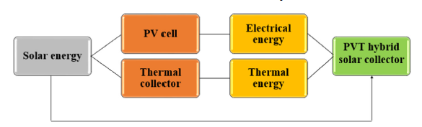

Fig. 45. Concept of PVT solar collector [7]

Some typical PVT collector designs are given in figure 46.

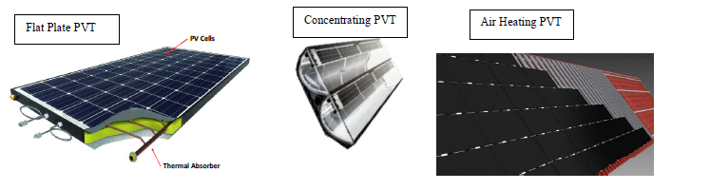

Fig. 46. Some examples of different PVT collector designs for combined heat and electricity production.

To maintain the solar panels at optimum efficiency and fully utilize the long wavelength radiation of the sun, the heat on solar panels is desired to be removed from the photovoltaic layer. The photovoltaic thermal collectors are thus designed by combining photovoltaic cells with heat-removing components (Figure 47). This allowed the solar panels to reach their maximum efficiency by reducing the temperature and, in the meantime, harvested the extra thermal energy. The PV/T technology works extraordinarily with households since the thermal energy can be directly used for heating. During these years, PVT panels have incorporated flat plate photovoltaic solar systems, heat pipes with various heat transporters like water, air and refrigerants.

There are many system types really suitable for PVT to start with, already now. They are here classified after the heating/cooling demand, as the electricity always can be utilized locally and even can be exported, if too much power is produced.

1. Hot water preheating systems for hotels and other large Hot water users.

2. Swimming pool heating.

3. PVT systems recharging Borehole/Ground Source heat pump systems to increase the Heat Pump COP and avoid undercooling of the borehole/ground. PVT can also be applied when changing to a larger heat pump in an existing ground source system.

4. Air heating systems. For example, preheating of ventilation air or preheating of summer houses. Also drying of crops can be achieved. Many industry applications with large ventilation air use, like painting, can be interesting.

5. Cooling by radiation to clear night sky conditions, can also be used as an extra bonus with the same hybrid components.

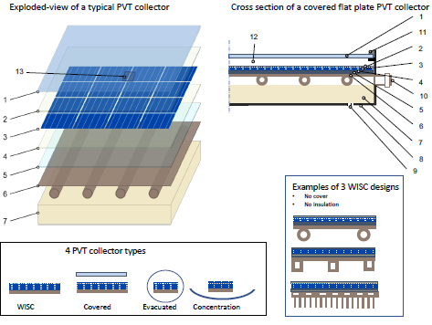

Fig. 47. Schematic cross section of WISC (wind and infrared sensitive collector) PVT collector: 1-transparent cover (optional), 2a- front cover of PV module, 2b-encapsulant, 3-solar PV cells connected, 4-encapsulant (optional), 5a-backsheet / rear cover of PV module (optional), 5b-glue / encapsulant (optional), 6a-absorber, 6b-heat transfer medium, 7-insulation (optional), 8-casing (optional), 9-air vent (optional), 10-fluid outlets, 11-sealing, 10-gap (optional only if 1 is present), 13-junction box [8].

Current research focuses on the integration of PV systems with the building. It is important that PV/T installations are in harmony with the building architectural design. The main target in PV/T systems is to achieve low costs for PV/T systems that produce electricity and thermal energy. Reducing system costs is the basic requirement for the widespread use of PV/T systems.

The main benefits of PV/T systems can be listed as follows:

* The cost in PV/T systems is lower than two separate system installations.
* The total area required for the PV/T system installation is less than the area required for the PV system and the thermal system.
* PV and solar collectors use different part of the solar spectrum.
* Collectors use infrared waves, while solar cells use visible light waves. By using both systems together, solar energy is used more effectively.
* Thanks to PV/T systems, the thermal load of the building decreases due to the increase in insulation and surface shading in summer.
* With PV/T systems, a more aesthetic installation will be possible in terms of appearance compared to the installation of PV and Thermal systems separately on the exterior of the building [9].

## 3.1. PVT collector classification

Typically, PVT solar collectors are either classified as air or liquid PVT’s, characterized by its HTF (Heat Transfer Fluid). The latter being either water or water/glycol mixture. PVT air collectors are known by its high heat losses and therefore less sensitive to overheating, which leads to higher electrical efficiencies. On the other hand, PVT liquid collectors have a higher installation share, yet it has overheating issues, despite water having a higher heat capacity and thermal conductivity. Moreover, concentrating PVT collectors can be labelled by its concentration ratio in three different categories, such as low, medium and high concentration factors. Typically, low concentration PVT collectors are used as stationary (fixed collector tilt angle) solar energy systems, however high concentration PVT collectors require a tracking system, either one-axis or two-axis system.

As the specific suitability depends on electrical conversion efficiency, temperature and also its absorption coefficient [3], therefore a PVT system location is of most importance. Monocrystalline PV cells are commonly known to have the highest share at modular electricity production devices (e.g. both PVT and PV panels) due to their enhanced electrical efficiency and higher solar absorption compared to polycrystalline PV cells. Thin-film solar cell technologies (e.g. CIGS and CdTe), are typically characterized by their lower temperature coefficient, which makes them very attractive for higher HTF temperatures and module temperatures. In PVT applications, multi-junction PV solar cells are typically employed in high concentration solar energy systems, thus a contender for high HTF temperature PVT solar collectors.

Furthermore, the developments in heat pump technology, and the increasing interest in Building Integrated PV (BIPV) and Façade Integrated PV (FIPV) are generating more opportunities for PVT applications to enter the super competitive PV module market. Therefore, in 2018, under the management of the International Energy Agency (IEA) Solar Heating and Cooling (SHC) programme, a task force composed by several experts (either from PVT companies or research institutes with PVT research programs) in PVT technology, has been initiated under the IEA-SHC Task 60: ‘Application of PVT collectors’. To help different stakeholders to have a better understanding of what kind of PVT technologies exists and its system characteristics, Lämmle et al. (2020) [10] presented and allocated, Figure 48, each PVT collector technology according to their:

Specific operating temperature ranges;

System layout;

Design (glazed, unglazed, and concentrating);

Heat Transfer Fluid, HTF (air and water/glycol, for commercial systems).

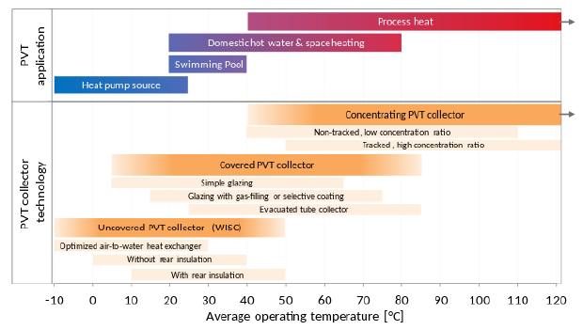

Fig. 48. Map of PVT technologies and applications per operating temperature [10]

Additionally, the generality of the PVT water collectors and solar flat-plate thermal collectors can be divided into their range of applications such as:

Low-temperature applications (~27-35°C) including swimming pool heating or spa heating.

HTF temperatures (~27-50 °C) are a prerequisite for space heating or integration with low- temperature heat pumps;

Medium temperature applications for temperatures up to 80°C (e.g. unglazed collectors in high irradiance climates, or with glass cover flat-plate collectors);

High-temperature applications for temperatures larger than 80°C, such as applications comprising high-efficiency flat-plate thermal collectors (with reduced thermal losses) or evacuated flat-plate collectors.

## 3.2. Performance of PVT Collectors

Solar radiation reaches the module at a solar irradiance of *G* where a fraction is lost to the ambient as *Qloss* and the remaining portion empowers the PV module (*Qel*) with a given electric efficiency (*ηel*). The accumulation of solar energy increases the temperature of the PV module and generates the thermal power of *Qth*, depending on the fluid medium and module design which is transferred to the thermal module through a heat transfer mechanism with a thermal efficiency of *ηth*. Finally, thermal insulation obtained by reducing and eliminating the back and sides heat losses and makes the entire system more efficient. The general energy equation in a simple PVT module and overall efficiency (*ηPVT*) can be defined by equations [11,12]:

${}_{el}=\frac{Q_{el}}{GA}$, (6)

${}_{th}=\frac{Q_{th}}{GA}$, (7)

${}_{PVT}={}_{el}+{}_{th}$, (8)

where *G* (W/m2) is the solar radiation and *A* (m2) is the aperture area of the module.

PVT systems are two separate systems consisting of one solar collector and a PV module. They are connected together and produce electricity and heat at the same time. We talked about *ηel* in section 2.2 (equations 4, 5), while thermal efficiency, based on ISO 9806: 2017 at steady-state condition for glazed liquid heating collectors, shall be calculated by statistical curve fitting, using the least squares method, to obtain an instantaneous efficiency curve of the form presented in next equation

${}_{th}={}_{o,th}-{}_{1}\frac{T_{m}-T_{a}}{G}-{}_{2}\frac{{{(T}_{m}-T_{a})}^{2}}{G}$, (9)

where *Tm* is mean temperature of heat transfer fluid (°C), *Ta* is ambient air temperature (°C), *η0,th* is peak collector efficiency (*ηth* at *Tm*-*Ta* = 0), *G* is hemispherical irradiance, *a*1 is heat loss coefficient (W/(m2·K)) and the temperature dependence of the heat loss coefficient comes as *a*2 (W/(m2·K2)) [13]

The performances of PV/T systems increase with the increase in temperature, but decrease when they start to operate at higher temperatures. For this reason, it is necessary to operate the PV modules at low temperatures in order to have the electrical efficiency of the PV cells at a certain level. Due to this necessity, the working areas of PV/T systems are limited. Therefore, the heat obtained can be used for preheating, water heating, space heating, etc. in buildings.

PV/T systems can be examined in 4 groups.

1. PV/T air collectors

2. PV/T liquid collectors

3. PV/T collectors with heat pipes

4. PV/T collectors with Phase Change Material [9].

PV/T systems are used in building applications, Solar distillation applications, Solar Energy drying applications, Greenhouse applications, Thermoelectric Generators and heat pumps.

When PV/T systems are examined, it is seen that these systems have the following advantages.

* By lowering the operating temperatures of PV cells, they increase the electrical efficiency of PV cells, which decreases with temperature.
* They increase the electrical and thermal efficiency of the system.
* More heat and electrical energy is obtained from the area where the PV/T system is installed. This is important as roof surface areas are limited.
* Hybrid PV/T systems create a more aesthetic appearance as they provide architectural integrity on the roof.

### 3.2.1. Air PV/T systems

Air PV/T systems are systems that operate at efficiencies between 20% and 40% [9]. The sum of the PV module efficiency and the system thermal efficiency represents the overall efficiency in PV/T systems. Therefore, it may be possible to achieve high efficiencies by performing different designs. In air PV/T systems, the air flow rate plays an important role in reducing the temperature of the PV cells, thus increasing the system efficiency by increasing the electrical efficiency. Air is used as the heat transfer fluid in air PV/T systems. The structures of these systems are simple and their operating costs are low. In addition, they have a common usage area because they can be integrated into buildings and so on (Figure 49).

Efficiency in PV/T systems is examined in two ways as electrical and thermal efficiency. With the increase in temperature, the electrical efficiency of PV cells decreases. Thermal efficiency is as important as electrical efficiency in PV/T systems. These systems are mostly the systems installed as building integrated PV systems (BEPVT). In BEPVT applications, the cooling of the PV panels is carried out with the air circulated in the air gap between the panels and the building material. In this way, the heated air can be used to heat the building. BEPVT systems have a more aesthetic appearance by adapting better to the outer surface of the building compared to other solar energy systems in their installations.

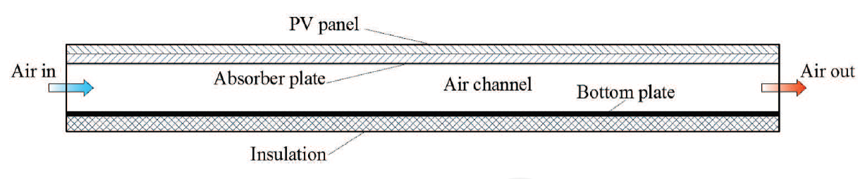

Fig. 49. PV/T air system section [14]

Because of these advantages, BEPVT systems are one of the fastest growing areas of the photovoltaic industry. In BEPVT systems, the air fluid velocity is generally low, but the wind speed also plays an important role. The velocity of the air circulated in the system and the duct design affect module efficiencies. Electrical efficiency in BEPVT systems is approximately 10% better than systems without cooling [14].

### 3.2.2. Liquid PV/T systems

Apart from Air PV/T systems, the most popular systems are Liquid PV/T systems. Because liquid PV/T systems are higher efficiency systems than air systems. Water is widely used to cool PV/T systems due to its low price, easy accessibility and cooling properties. PV cells can be cooled more evenly when water is used as the heat transfer fluid. Due to the high thermal conductivity of liquids, these systems have an important place compared to air systems.

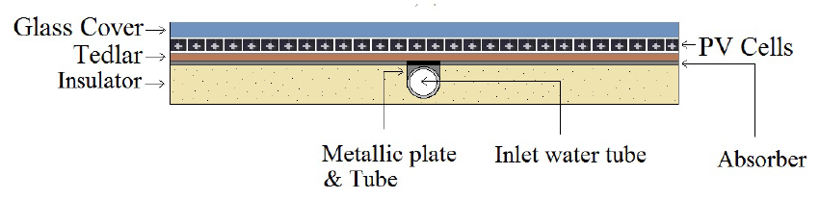

Fig. 50. Sectional view of water-based photovoltaic-thermal (PV/T) collector [15]

In liquid PV/T systems, the type of fluid used affects the amount of heat transfer. The fluid used in these systems is usually water. The fact that water is easily accessible, has good heat transfer properties and is cheap increases the usability of this fluid.

### 3.2.3. Heat Pipe PV/T systems

PV/T collector systems using water as the heat transfer fluid are not recommended in places where the climatic conditions are cold. If the water freezes at a low temperature and increases in volume, it can cause damage to the system. The heat pipe is a system with high thermal conductivity that allows heat to be transported quickly without reducing the temperature. Freezing can be prevented with the right fluid. A heat pipe PV/T system can be created by combining the heat pipe and the solar collector. Figure 13 shows the general structure of a heat pipe PV/T system.

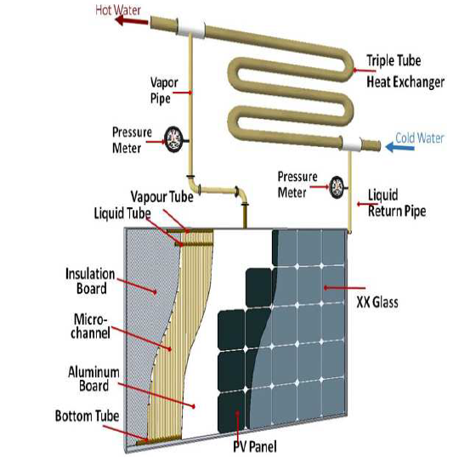

Fig. 51. PV/T system section with heat pipe [16].

### 3.2.4. PV/T systems with PCM

These collectors are in the early development stage and are similar to water-based collectors where water flows within the tubes. Additionally, it utilizes phase change material (PCM) within the PCM unit which is placed at the back of the PV module. A PCM material takes in or discharges an ample amount of energy during phase transition to provide heating or cooling. Water tubes are integrated with the PCM unit as presented in Figure 52, which absorbs and stores the heat within the material from the PV module. PCM materials have high energy storage density, high thermal conductivity, and chemical stability. During day time, these collectors operate normally when the solar radiation is available but during night time, the stored heat within the PCM material is used for heating purpose. Quantity and selection of these materials are very crucial because materials with low thermal conductivity will have a slow heat transfer and will not provide the required thermal energy. PCM materials used in PV/T collectors are divided into two categories, organic and inorganic. Organic PCM materials are derived from plants, animals, or petroleum products. These materials are safe, can be recycled but have low thermal conductivity. Inorganic PCM materials are cheaper, easily available, and have high thermal conductivity [17].

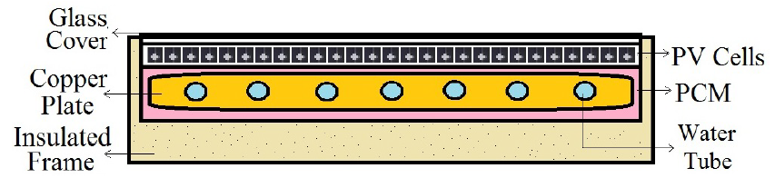

Fig. 52. Sectional view of PCM- based PV/T collector [15]

### 3.2.5. Heat Pump Integrated with a PV/T Collector

The priority is to save energy and lower the cost for the purpose of heating and cooling. The heat pump integrated with a PV/T system is more efficient than a standard PV/T heating/cooling system. These devices take heat from a low-temperature medium and transfer heat to a high-temperature medium. They can also work in places where the temperature gets extra chilly. The heat pump integrated with the PV/T system becomes less efficient when the ambient temperature drops because there is not enough heat produced by the PV/T system [15]. The major advantage of using a PV/T system is the combined production of both electricity and heat. The electricity generated by the collector can be used to raise the temperature in order to get the desired temperature. A PV/T collector assisted with a heat pump can be used for cooling the PV module.

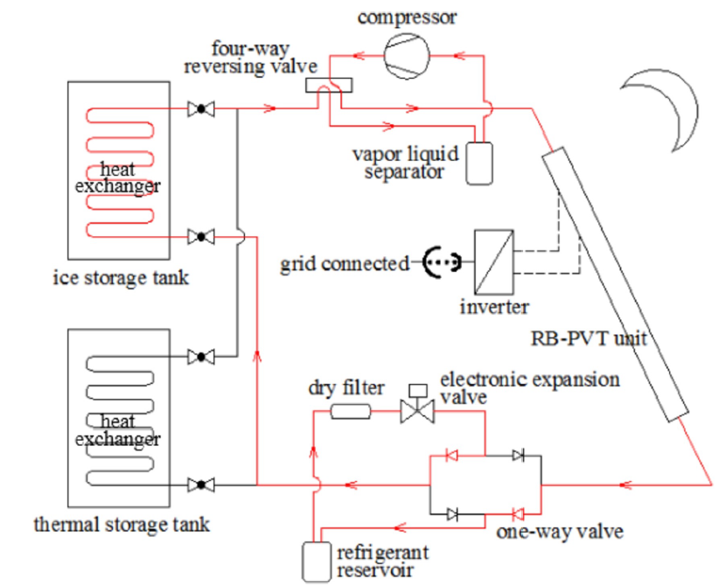

Fig. 53. Schematic diagram of the proposed PV/T heat pump system on refrigeration mode [18].

Noro and Lazzarin [18] evaluated the economic performance of the hybrid PV/T heat pump system using eight PV/T collectors for a two-stage Italian house with a volume of 364 m3. In order to obtain domestic hot water, the inlet water temperature is set around 12° C and the water delivered to the user is 45° C. A control system is proposed to drive the system:

* For space heating, a three-way valve is supposed to bypass the storage if the temperature of the storage tank is lower than the water temperature from the radiant floor plant.
* Pump turns on if the solar radiation is >300 W/m2 and the temperature from PV/T collector is >7° C than storage temperature.
* Pump turns off if the temperature from PV/T collector is <3° C and not taking solar radiation into account.

|  |
| --- |
| Tick the correct option for the following statements.   1. Evaluate the space requirement required for the installation of PV/T systems, according to the separate PV system and Solar system installations.    1. The need for space is greater b) The need for space is less c) The need for space is the same 2. Evaluate PV/T system installations in terms of aesthetics according to separate PV system and Solar system installations.    1. Aesthetically better b) Aesthetically worse c) Aesthetically the same 3. Evaluate the efficiency of PV/T system installations according to the efficiency of PV system and Solar system installations separately.    1. Their yields are higher b) Their yields are lower c) Their yields are the same 4. Evaluate PV/T system installation costs according to the costs of PV system and Solar system installations separately.    1. Cost is higher b) Cost is lower c) Cost is the same   Write the answers to the following questions.   1. What are the PV/T system types? Write 2. What are the advantages of PV/T systems? Write 3. What are the disadvantages of PV/T systems? Write |

# EXPERIMENT

## 4.1. Research of photovoltaic cells

**Aim of the work:** To find the most effective energy point of photovoltaic cells by changing the angle of the photovoltaic elements.

**Job Task:**

1. Connect a short circuit diagram using a load resistor. The position of the resistor must be at 100.

a. The photovoltaic cells are supplied with power cords to COMBINER BOX.

b. The COMBINER BOX box connects the negative cable to the DISCONNECTED switch.

c. The negative cable from the circuit breaker is connected to the load resistor - contact (VARIABLE LOAD), and the positive wire from the COMBINER BOX is connected to the load resistor + contact.

|  |  |
| --- | --- |
|  |  |

Fig. Photovoltaic module on the 850-AE Solar PV Sun Simulator

2. Measure the resistance of the resistor positions and fill the table..

|  |  |  |  |
| --- | --- | --- | --- |
| Resistor position | Resistance, Ω | Resistor position | Resistance, Ω |
| 0 |  | 60 |  |
| 10 |  | 70 |  |
| 20 |  | 80 |  |
| 30 |  | 90 |  |
| 40 |  | 100 |  |
| 50 |  |  |  |

3. Measure and calculate the working points (power, W) of the photovoltaic cells, depending on the angle of inclination of the photovoltaic cells and the value of the load resistor, using the measuring devices assigned by the teacher. Fill in the data in the table. Power is calculated

|  |  |  |  |  |  |  |  |  |
| --- | --- | --- | --- | --- | --- | --- | --- | --- |
| Res. pos. Angle | 0 | 10 | 20 | 30 | 40 | 50 | 70 | 100 |
|  |  |  |  |  |  |  |  |  |
|  |  |  |  |  |  |  |  |  |
|  |  |  |  |  |  |  |  |  |
|  |  |  |  |  |  |  |  |  |
|  |  |  |  |  |  |  |  |  |

4. Draw a graph of resistance and power dependency. All data must fit in one chart.

5. Write the conclusions.

## 4.2. Principal operation of the stand 950-STCL1 (Solar thermal collector)

**Aim of the work:**

To find out the principles of operation of the stand 950-STCL1. Examine electrical and mechanical bench diagrams.

**Stand description:**

The stand 950-STCL1 consists of two flat solar collectors with two storage closed circuits. The first storage circuit includes solar collectors, a pump, a heat exchanger and a water storage tank (boiler). The system is filled with distilled water. The second storage circuit includes the following elements: a heat exchanger, a pump and a hot water storage tank. The systems are separated. The stand has mechanical and electrical imitation faults. The stand is controlled by a programmable controller that controls the switching on and off of the pumps. The controller measures the system and collector temperatures, which determines when the pumps are to be controlled.

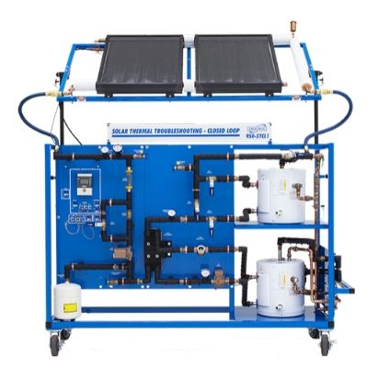

Solar thermal troubleshooting- closed loop learning system 950-STCL1

**Job Task:**

1. Draw the block diagram of the stand 950-STCL1. Mark the temperature sensors and actuators in the diagram
2. Draw the electricity diagram of the stand.
3. Describe the interaction of the mechanical and electrical components of the stand in the control of the solar collector.
4. Fault modeling. Fill in the table and describe the mechanical and electrical faults.

|  |  |  |
| --- | --- | --- |
| Nr. | Name | Fault description |
| 1. |  |  |
| 2. |  |  |
| 3. |  |  |
| 4. |  |  |
| 5. |  |  |
| 6. |  |  |
| 7. |  |  |
| 8. |  |  |

Write the conclusions

# References

European Commision. Photovoltaic Geographical Information System. Available online: [https://re.jrc.ec.europa.eu/pvg_download/map_index_c.html#](https://re.jrc.ec.europa.eu/pvg_download/map_index_c.html) (accessed on 18 February 2022).

Kaltschmitt, M.; Streicher, W.; Wiese, A. 2007. *Renewable energy: technology, economics and environment*. Springer, Verlag Berlin Heidelberg.

Smets A., Jager K., Isabella O., Swaaij R., Zeman M. 2016. *Solar energy: The physics and engineering of photovoltaic conversion, technologies and system*. Cambridge.

Best research cell efficiencies. <https://upload.wikimedia.org/wikipedia/commons/2/25/Best-research-cell-efficiencies-rev220126_pages-to-jpg-0001.jpg> (accessed on 10 March 2022).

Amatrol PV module operation (2014). Hands on skill for learning activity. USA, Amatrol.com

Yahyaoui I., (2018). *Advances in Reneable Energies and Power Technologies. Solar and Wind Energies*. Vol. 1. Elsevier

Herez, A.; el Hage, H.; Lemenand, T.; Ramadan, M.; Khaled, M. Review on photovoltaic/thermal hybrid solar collectors: Classifications, applications and new systems. Sol. Energy 2020, 207, 1321–1347. <https://doi.org/10.1016/j.solener.2020.07.062>

IEA SHC Task 60 report, Design Guidelines for PVT Collector. <https://task60.iea-shc.org/Data/Sites/1/publications/IEA-SHC-Task60-B2-Design-Guidelines-for-PVT-Collectors.pdf>

Oksuz M., Kose F. *Hybrid Photovoltaic Thermal PVT-water and PVT-air Solar Collectors Analysis*. National Environmental Sciences Research Journal, Issue 2(3): 95-102, 2019.

Lämmle, M.; Herrando, M.; Ryan, G. 2020. *IEA SHC Task 60 - Basic concepts of PVT collector technologies, applications and markets*.

Ramos, C.A.F.; Alcaso, A.N.; Cardoso, A.J.M. Photovoltaic-thermal (PVT) technology: Review and case study. In Proceedings of the IOP Conference Series: Earth and Environmental Science; IOP Publishing, 2019; Vol. 354, p. 12048.

Shakouri, M.; Ebadi, H.; Gorjian, S. Solar photovoltaic thermal (PVT) module technologies. In Photovoltaic Solar Energy Conversion; Elsevier, 2020; pp. 79–116.

ISO9806:2017 ISO 9806:2017. Solar Energy-Solar Thermal Collectors-Test Methods; ISO, 2017

Zhenjun M., Haoshan R., Wenye L. and Shugang W. *Solar-Assisted HVAC Systems with Integrated Phase Change*. December 20th 2017. <http://dx.doi.org/10.5772/intechopen.72187>

Ul Abdin, Z., Rachid, A. *A survey on applications of hybrid PV/T panels.* Energies, 2021, 14(4), 1205. <https://doi.org/10.3390/en14041205>

Diallo T.M.O.,. Zhou M. Yu, J, Zhao X., Shittu S., Li G., Ji J., Hardy D. *Energy performance analysis of a novel solar PVT loop heat pipe employing a microchannel pipe evaporator and a heat PCM triple heat exchange*. 13 November 2018, <https://doi.org/10.1016/j.energy.2018.10.192>

Mofijur, M.; Mahlia, T.M.I.; Silitonga, A.S.; Ong, H.C.; Silakhori, M.; Hasan, M.H.; Putra, N.; Rahman, S. *Phase change materials (PCM) for solar energy usages and storage: An overview.* Energies 2019, 12, 3167, <https://doi.org/10.3390/en12163167>

Liang, R.; Zhou, C.; Zhang, J.; Chen, J.; Riaz, A. Characteristics analysis of the photovoltaic thermal heat pump system on refrigeration mode: An experimental investigation. Renew. Energy 2020, 146, 2450–2461. https://doi.org/10.1016/j.renene.2019.08.045

Noro, M.; Lazzarin, R.M. Hybrid PhotoVoltaic–Thermal heat pump systems: Energy and economic performance evaluations in different climates. Int. J. Low Carbon Technol. 2018, 13, 76–83. <https://doi.org/10.1093/ijlct/ctx022>